UNITED STATES
SECURITIES AND EXCHANGE COMMISSION
Washington, D.C. 20549

FORM 8-K

CURRENT REPORT
Pursuant to Section 13 OR 15(d) of The Securities Exchange Act of 1934

Date of Report (Date of earliest event reported) August 3, 2026

Comfort Systems USA, Inc.
(Exact name of registrant as specified in its charter)

Delaware |  | 1-13011 |  | 76-0526487
(State or other jurisdiction |  | (Commission |  | (IRS Employer
of incorporation) |  | File Number) |  | Identification No.)

9753 Katy Freeway, Suite 700
Houston, Texas |  | 77024
(Address of principal executive offices) |  | (Zip Code)

Registrant’s telephone number, including area code (713) 830-9600

(Former name or former address, if changed since last report.)

Check the appropriate box below if the Form 8-K filing is intended to simultaneously satisfy the filing obligation of the registrant under any of the following provisions:

☐ Written communications pursuant to Rule 425 under the Securities Act (17 CFR 230.425)
☐ Soliciting material pursuant to Rule 14a-12 under the Exchange Act (17 CFR 240.14a-12)
☐ Pre-commencement communications pursuant to Rule 14d-2(b) under the Exchange Act (17 CFR 240.14d-2(b))
☐ Pre-commencement communications pursuant to Rule 13e-4(c) under the Exchange Act (17 CFR 240.13e-4(c))

Securities registered pursuant to Section 12(b) of the Act:

Title of each class |  | Trading Symbol(s) |  | Name of each exchange on which registered
Common Stock, $0.01 par value |  | FIX |  | New York Stock Exchange

Indicate by check mark whether the registrant is an emerging growth company as defined in Rule 405 of the Securities Act of 1933 (§230.405 of this chapter) or Rule 12b-2 of the Securities Exchange Act of 1934 (§240.12b-2 of this chapter).

Emerging growth company ☐

If an emerging growth company, indicate by check mark if the registrant has elected not to use the extended transition period for complying with any new or revised financial accounting standards provided pursuant to Section 13(a) of the Exchange Act. ☐

ITEM 7.01 Regulation FD Disclosure

On August 3, 2026, Comfort Systems USA, Inc., a Delaware corporation (the “Company”), a leading provider of commercial, industrial and institutional heating, ventilation, air conditioning and electrical contracting services, posted to the “Investors” section of its website (https://comfortsystemsusa.com) an investor presentation slideshow. The Company intends to use this slideshow in making presentations to analysts, potential investors, and other interested parties.

The information included in the investor presentation includes financial information determined by methods other than in accordance with accounting principles generally accepted in the United States of America (“GAAP”). The Company’s management uses these non-GAAP measures in its analysis of the Company’s performance. The Company believes that the presentation of certain non-GAAP measures provides useful supplemental information that is essential to a proper understanding of the operating results of the Company’s core businesses. These non-GAAP disclosures should not be viewed as a substitute for operating results determined in accordance with GAAP, nor are they necessarily comparable to non-GAAP performance measures that may be presented by other companies.

The information in this Form 8-K being furnished under Item 7.01 shall not be deemed to be “filed” for the purposes of Section 18 of the Securities Exchange Act of 1934, as amended (the “Exchange Act”), or otherwise subject to the liabilities of such section, nor shall such information be deemed incorporated by reference in any filing under the Securities Act of 1933, as amended, or the Exchange Act, except as shall be expressly set forth by specific reference in such a filing. The investor presentation contains forward-looking statements within the meaning of applicable securities laws and regulations. These statements are based on the Company’s expectations and involve risks and uncertainties that could cause the Company’s actual results to differ materially from those set forth in the statements. These risks are discussed in the Company’s filings with the Securities and Exchange Commission, including an extensive discussion of these risks in the Company’s Annual Report on Form 10-K for the year ended December 31, 2025.

A copy of the presentation is furnished herewith as Exhibit 99.1.

ITEM 9.01 Financial Statements and Exhibits

(d) Exhibits.

Exhibit  Number |  | Description
99.1 |  | Investor presentation dated August 3, 2026
104 |  | Cover Page Interactive Data File (the cover page XBRL tags are embedded within the Inline XBRL document).

SIGNATURES

Pursuant to the requirements of the Securities Exchange Act of 1934, the Registrant has duly caused this report to be signed on its behalf by the undersigned hereunto duly authorized.

 |  | COMFORT SYSTEMS USA, INC.
 | By: | /s/ Rachel R. Eslicker
Rachel R. Eslicker
Senior Vice President and General Counsel

Date: August 3, 2026

Exhibit 99.1

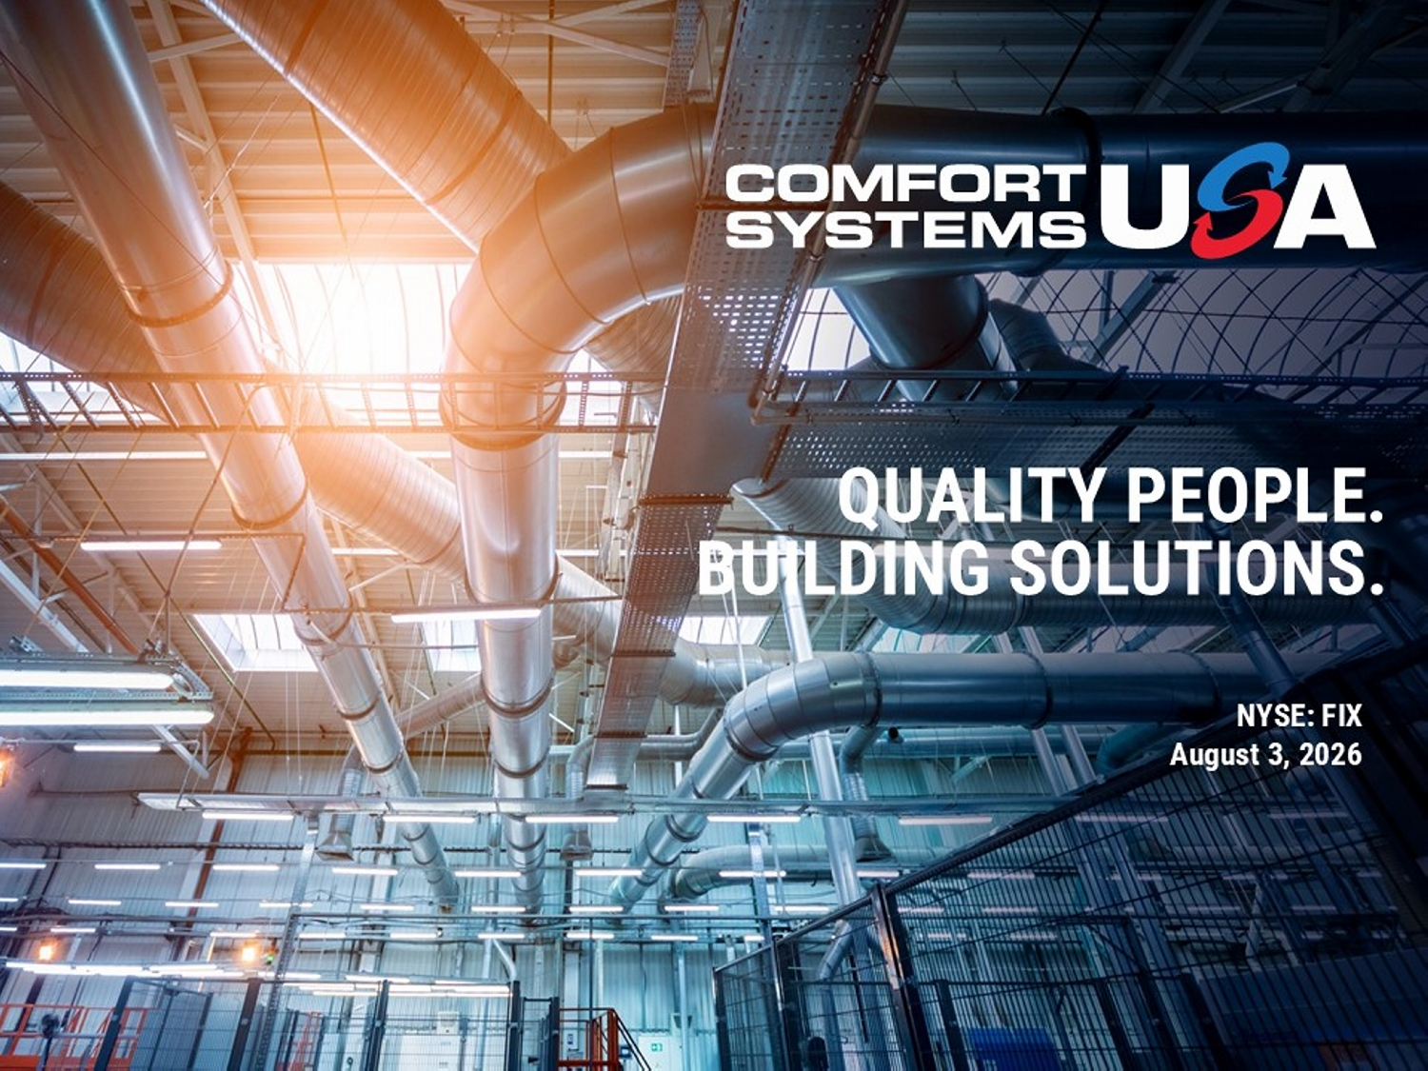
QUALITY PEOPLE. BUILDING SOLUTIONS. NYSE: FIX August 3, 2026

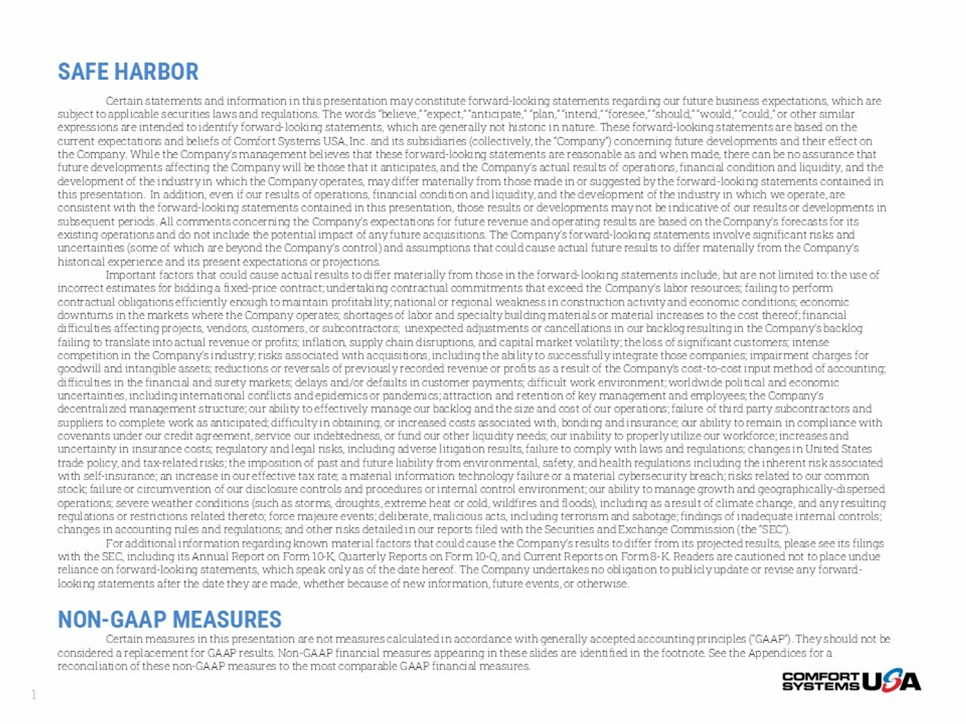
SAFE HARBOR Certain statements and information in this presentation may constitute forward - looking statements regarding our future business expectations, which are subject to applicable securities laws and regulations. The words “believe,” “expect,” “anticipate,” “plan,” “intend,” “forese e,” “should,” “would,” “could,” or other similar expressions are intended to identify forward - looking statements, which are generally not historic in nature. These forward - looki ng statements are based on the current expectations and beliefs of Comfort Systems USA, Inc. and its subsidiaries (collectively, the “Company”) concerning f utu re developments and their effect on the Company. While the Company’s management believes that these forward - looking statements are reasonable as and when made, ther e can be no assurance that future developments affecting the Company will be those that it anticipates, and the Company’s actual results of operations, fin ancial condition and liquidity, and the development of the industry in which the Company operates, may differ materially from those made in or suggested by the forwa rd - looking statements contained in this presentation. In addition, even if our results of operations, financial condition and liquidity, and the development of th e industry in which we operate, are consistent with the forward - looking statements contained in this presentation, those results or developments may not be indicati ve of our results or developments in subsequent periods. All comments concerning the Company’s expectations for future revenue and operating results are based on the Company’s forecasts for its existing operations and do not include the potential impact of any future acquisitions. The Company’s forward - looking statements involve significant risks and uncertainties (some of which are beyond the Company’s control) and assumptions that could cause actual future results to diff er materially from the Company’s historical experience and its present expectations or projections. Important factors that could cause actual results to differ materially from those in the forward - looking statements include, bu t are not limited to: the use of incorrect estimates for bidding a fixed - price contract; undertaking contractual commitments that exceed the Company’s labor reso urces; failing to perform contractual obligations efficiently enough to maintain profitability; national or regional weakness in construction activity and economic conditions; economic downturns in the markets where the Company operates; shortages of labor and specialty building materials or material increase s t o the cost thereof; financial difficulties affecting projects, vendors, customers, or subcontractors; unexpected adjustments or cancellations in our backl og resulting in the Company’s backlog failing to translate into actual revenue or profits; inflation, supply chain disruptions, and capital market volatility; the los s of significant customers; intense competition in the Company’s industry; risks associated with acquisitions, including the ability to successfully integrate th ose companies; impairment charges for goodwill and intangible assets; reductions or reversals of previously recorded revenue or profits as a result of the Company’ s c ost - to - cost input method of accounting; difficulties in the financial and surety markets; delays and/or defaults in customer payments; difficult work environment; wo rld wide political and economic uncertainties, including international conflicts and epidemics or pandemics; attraction and retention of key management and e mpl oyees; the Company’s decentralized management structure; our ability to effectively manage our backlog and the size and cost of our operations; fa ilu re of third party subcontractors and suppliers to complete work as anticipated; difficulty in obtaining, or increased costs associated with, bonding and insurance ; o ur ability to remain in compliance with covenants under our credit agreement, service our indebtedness, or fund our other liquidity needs; our inability to properly uti lize our workforce; increases and uncertainty in insurance costs; regulatory and legal risks, including adverse litigation results, failure to comply with laws an d regulations; changes in United States trade policy, and tax - related risks; the imposition of past and future liability from environmental, safety, and health regulati ons including the inherent risk associated with self - insurance; an increase in our effective tax rate; a material information technology failure or a material cybersecurit y breach; risks related to our common stock; failure or circumvention of our disclosure controls and procedures or internal control environment; our ability to man age growth and geographically - dispersed operations; severe weather conditions (such as storms, droughts, extreme heat or cold, wildfires and floods), including as a res ult of climate change, and any resulting regulations or restrictions related thereto; force majeure events; deliberate, malicious acts, including terrorism and sabota ge; findings of inadequate internal controls; changes in accounting rules and regulations; and other risks detailed in our reports filed with the Securities and Exchange C omm ission (the “SEC”). For additional information regarding known material factors that could cause the Company’s results to differ from its project ed results, please see its filings with the SEC, including its Annual Report on Form 10 - K, Quarterly Reports on Form 10 - Q, and Current Reports on Form 8 - K. Readers are cautioned not to place undue reliance on forward - looking statements, which speak only as of the date hereof. The Company undertakes no obligation to publicly update or revise any forward - looking statements after the date they are made, whether because of new information, future events, or otherwise. NON - GAAP MEASURES Certain measures in this presentation are not measures calculated in accordance with generally accepted accounting principles ( “GAAP”). They should not be considered a replacement for GAAP results. Non - GAAP financial measures appearing in these slides are identified in the footnote. See the Appendices for a reconciliation of these non - GAAP measures to the most comparable GAAP financial measures. 1

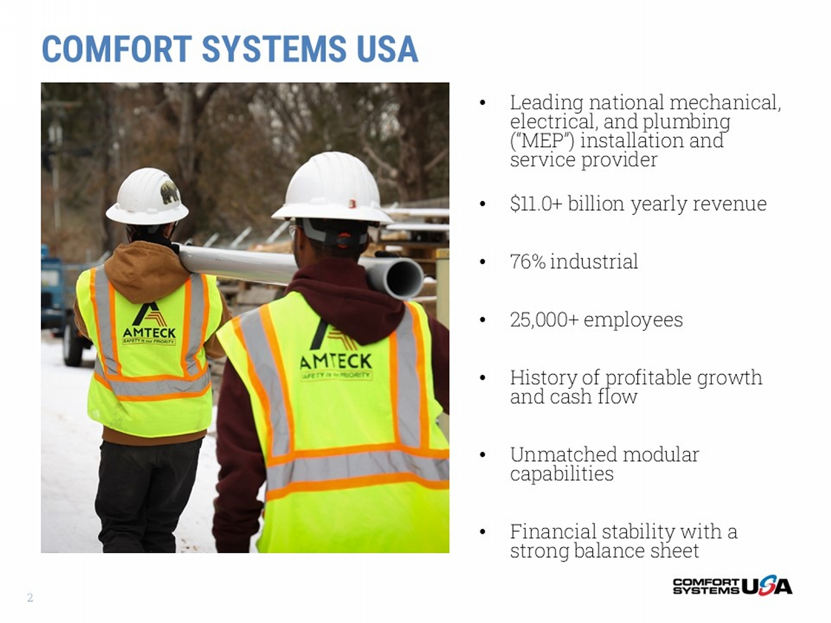
• Leading national mechanical, electrical, and plumbing (“MEP”) installation and service provider • $11.0+ billion yearly revenue • 76% industrial • 25,000+ employees • History of profitable growth and cash flow • Unmatched modular capabilities • Financial stability with a strong balance sheet COMFORT SYSTEMS USA 2

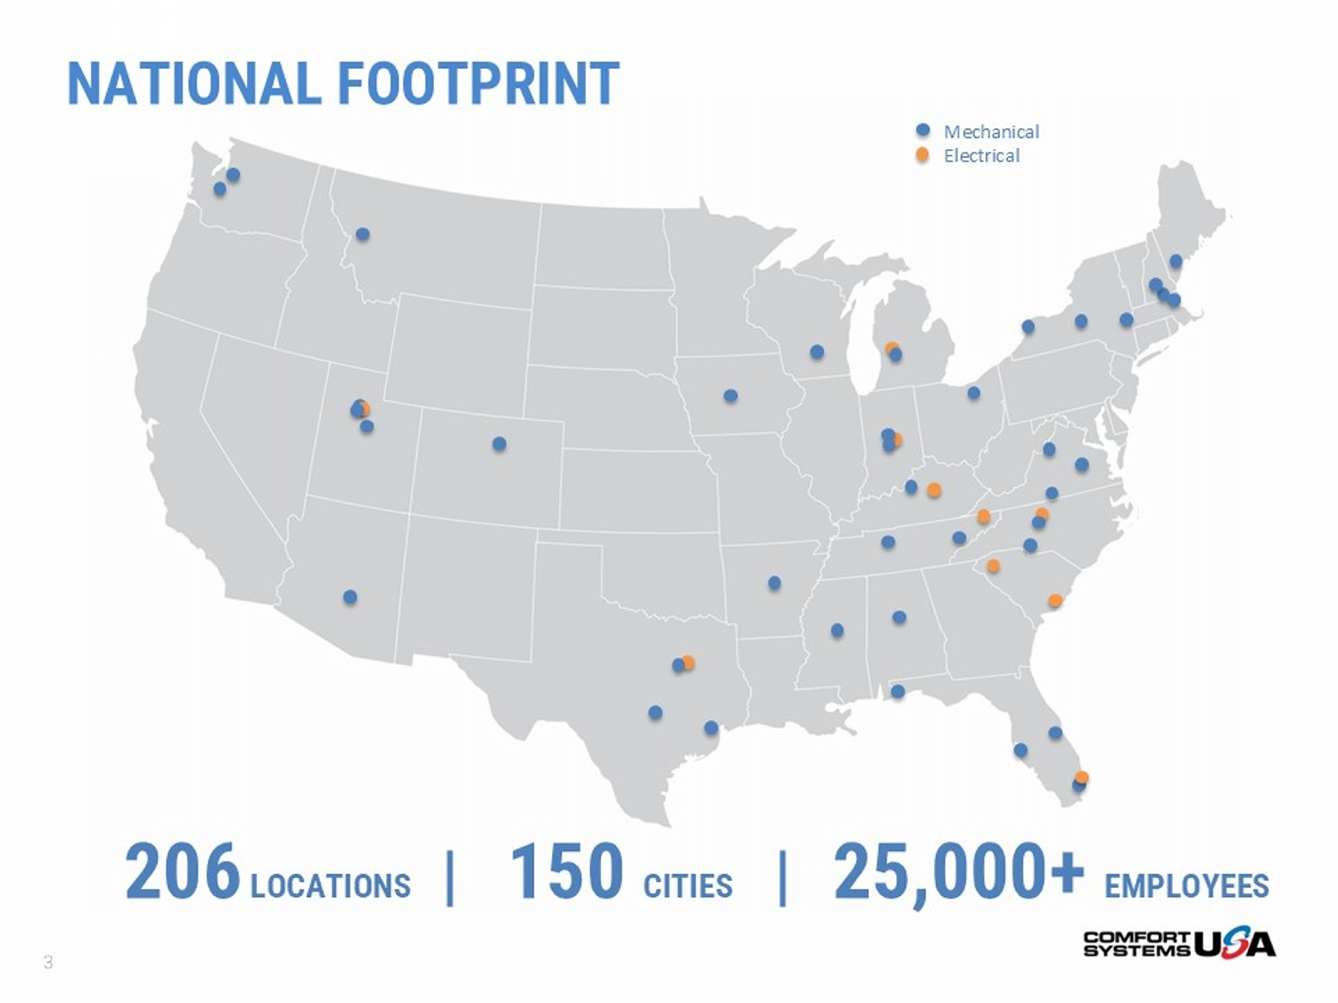
206 LOCATIONS | 150 CITIES | 25 ,000+ EMPLOYEES NATIONAL FOOTPRINT 3 Mechanical Electrical

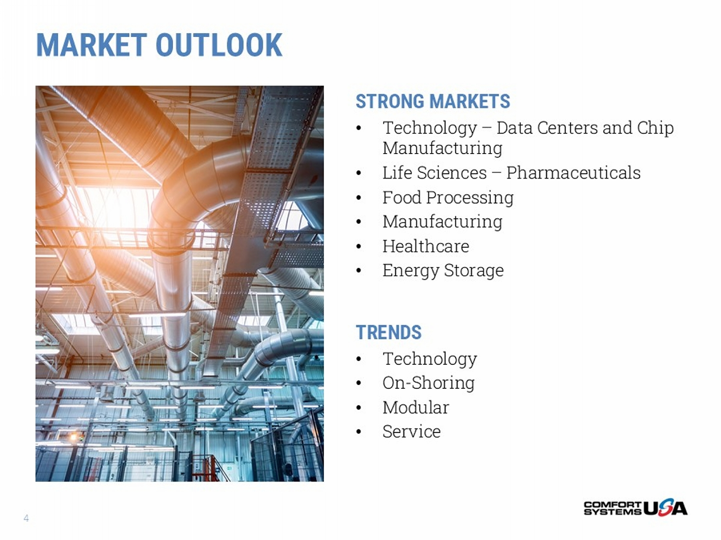
MARKET OUTLOOK STRONG MARKETS • Technology – Data Centers and Chip Manufacturing • Life Sciences – Pharmaceuticals • Food Processing • Manufacturing • Healthcare • Energy Storage TRENDS • Technology • On - Shoring • Modular • Service 4

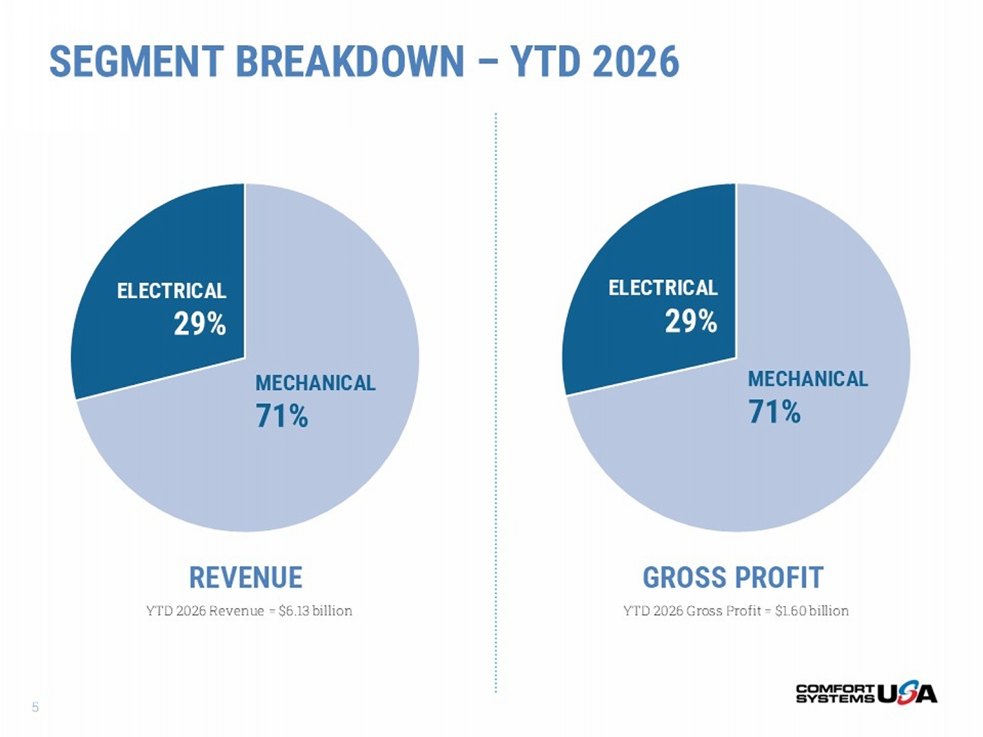
REVENUE GROSS PROFIT YTD 2026 Gross Profit = $1.60 billion YTD 2026 Revenue = $6.13 billion SEGMENT BREAKDOWN – YTD 2026 MECHANICAL 71% ELECTRICAL 29% MECHANICAL 71% ELECTRICAL 29% 5

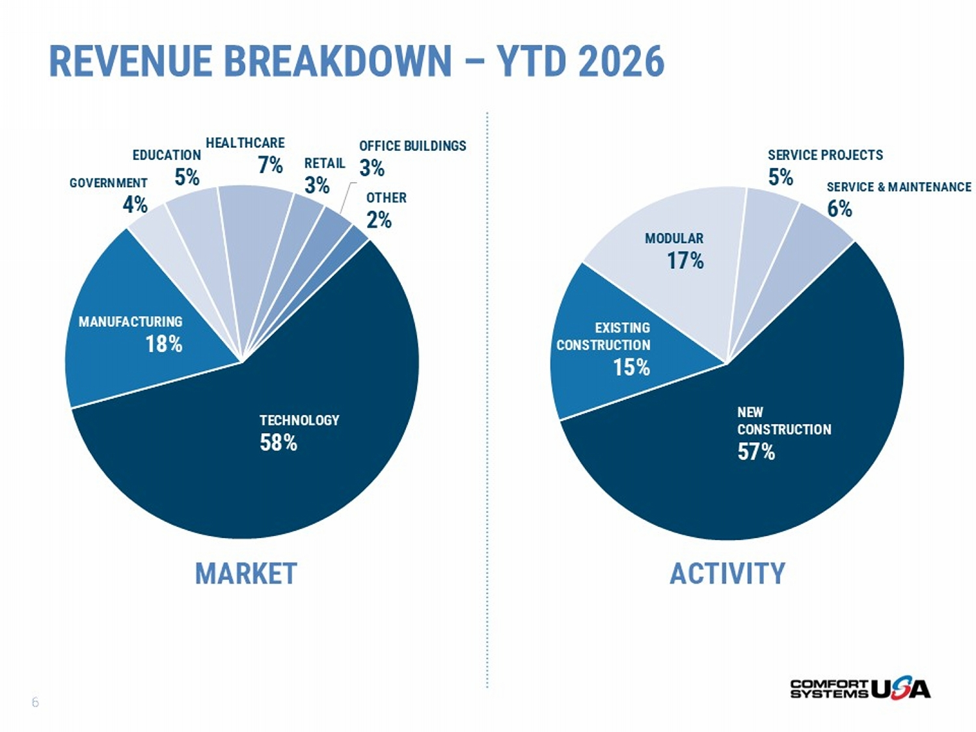
MARKET ACTIVITY REVENUE BREAKDOWN – YTD 2026 TECHNOLOGY 58% MANUFACTURING 18% GOVERNMENT 4% EDUCATION 5% HEALTHCARE 7% RETAIL 3% OFFICE BUILDINGS 3% OTHER 2% NEW CONSTRUCTION 57% EXISTING CONSTRUCTION 15% MODULAR 17% SERVICE PROJECTS 5% SERVICE & MAINTENANCE 6% 6

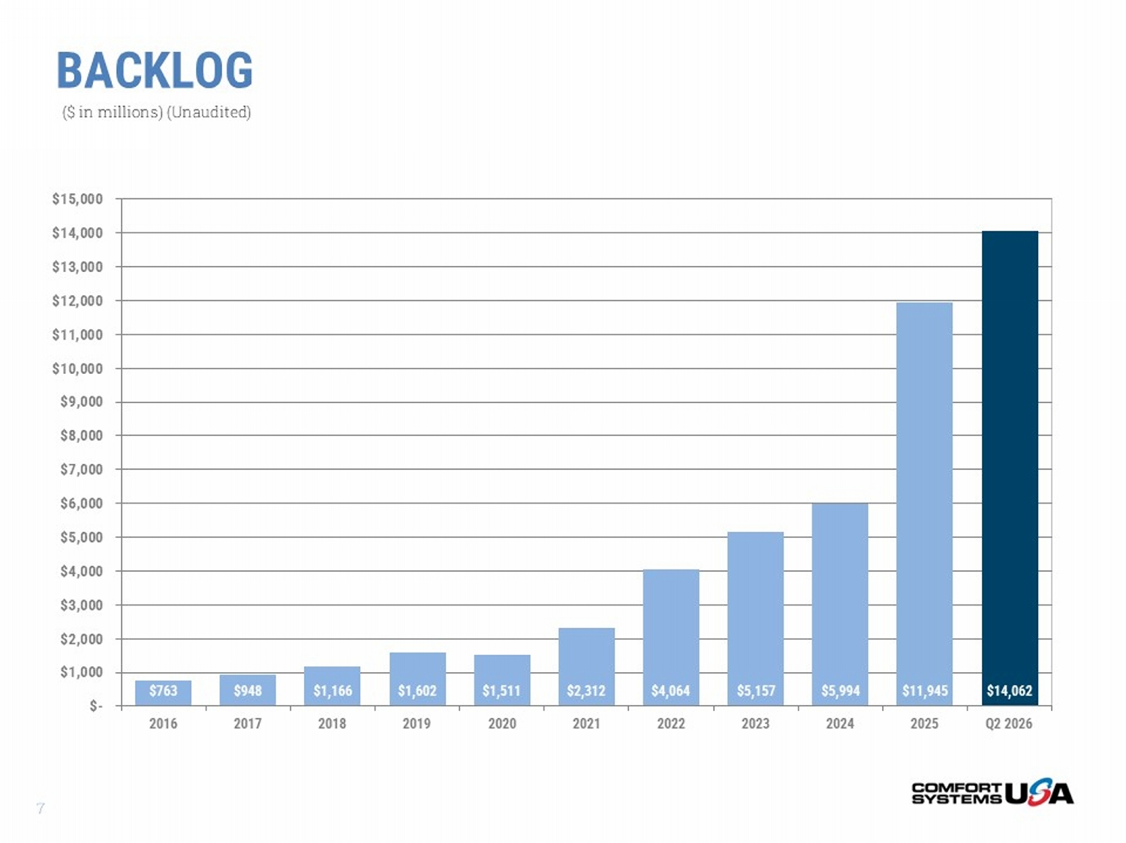
BACKLOG $763 $948 $1,166 $1,602 $1,511 $2,312 $4,064 $5,157 $5,994 $11,945 $14,062 $- $1,000 $2,000 $3,000 $4,000 $5,000 $6,000 $7,000 $8,000 $9,000 $10,000 $11,000 $12,000 $13,000 $14,000 $15,000 2016 2017 2018 2019 2020 2021 2022 2023 2024 2025 Q2 2026 ($ in millions) (Unaudited) 7

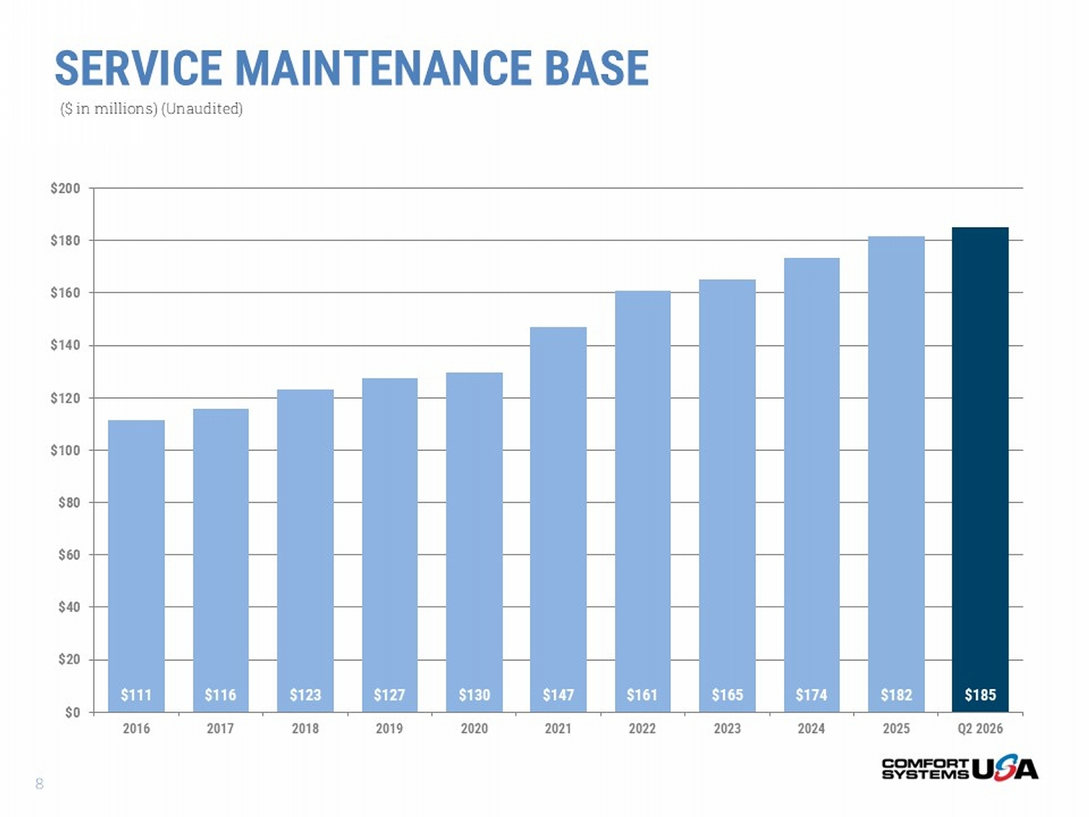
$111 $116 $123 $127 $130 $147 $161 $165 $174 $182 $185 $0 $20 $40 $60 $80 $100 $120 $140 $160 $180 $200 2016 2017 2018 2019 2020 2021 2022 2023 2024 2025 Q2 2026 SERVICE MAINTENANCE BASE ($ in millions) (Unaudited) 8

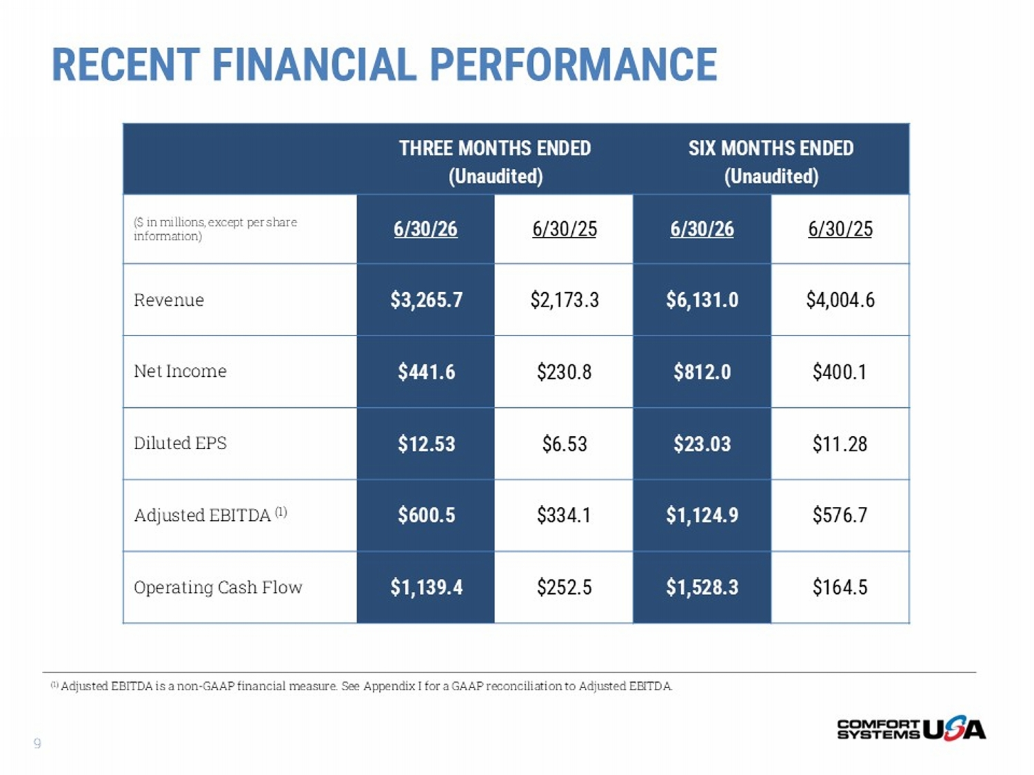
SIX MONTHS ENDED (Unaudited) THREE MONTHS ENDED (Unaudited) 6/30/25 6/30/26 6/30/25 6/30/26 ($ in millions, except per share information) $4,004.6 $6,131.0 $2,173.3 $3,265.7 Revenue $400.1 $812.0 $230.8 $441.6 Net Income $11.28 $23.03 $6.53 $12.53 Diluted EPS $576.7 $1,124.9 $334.1 $600.5 Adjusted EBITDA (1) $164.5 $1,528.3 $252.5 $1,139.4 Operating Cash Flow (1) Adjusted EBITDA is a non - GAAP financial measure. See Appendix I for a GAAP reconciliation to Adjusted EBITDA. RECENT FINANCIAL PERFORMANCE 9

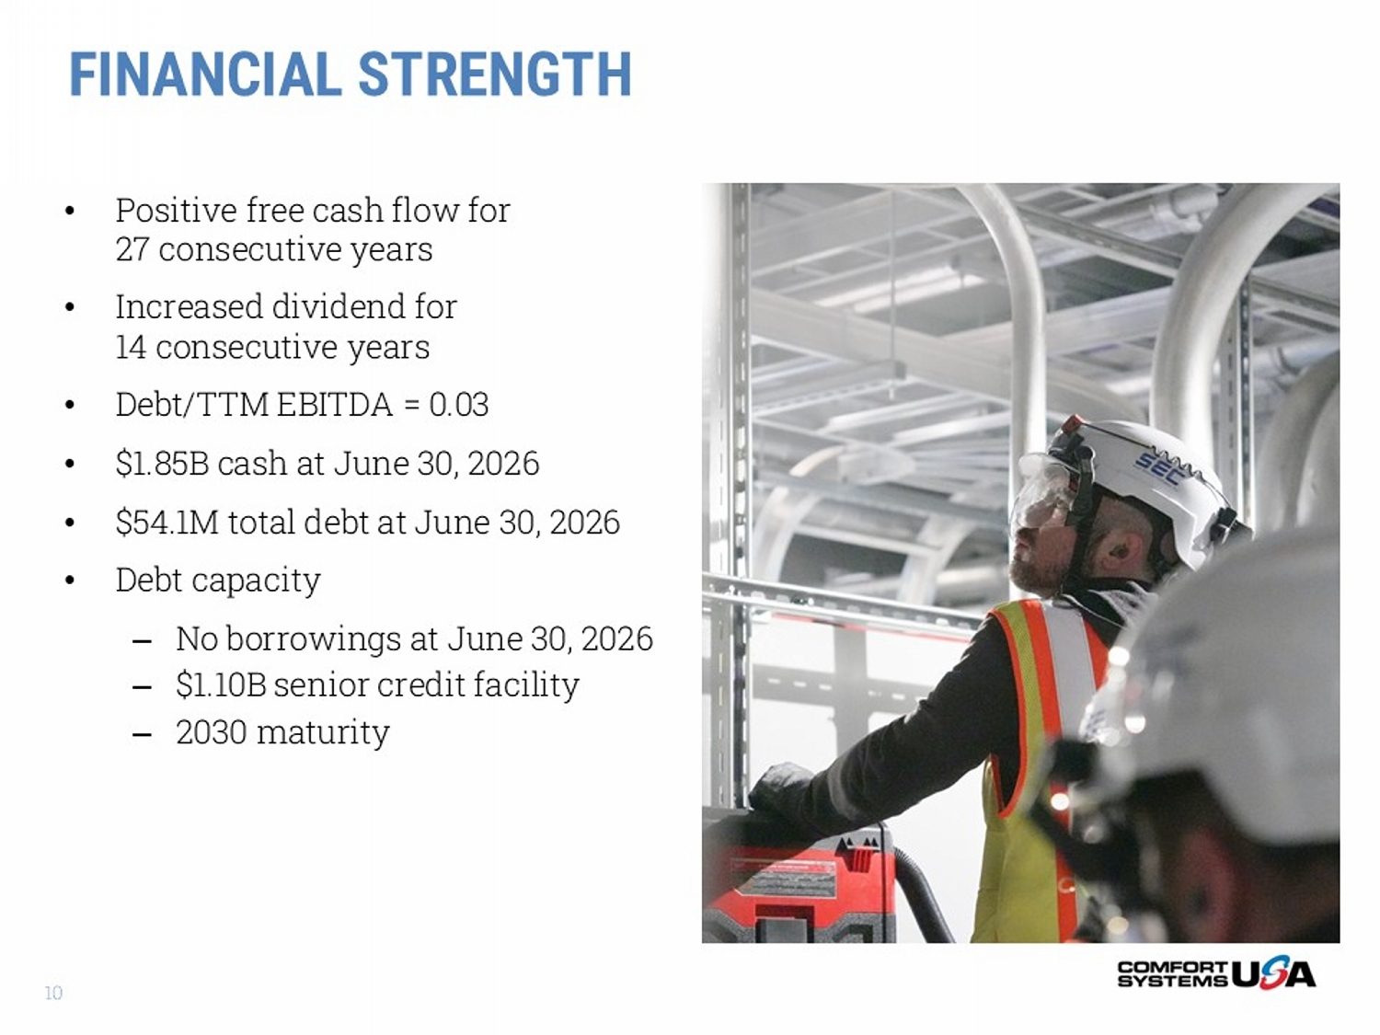
FINANCIAL STRENGTH • Positive free cash flow for 27 consecutive years • Increased dividend for 14 consecutive years • Debt/TTM EBITDA = 0.03 • $1.85B cash at June 30, 2026 • $54.1M total debt at June 30, 2026 • Debt capacity – No borrowings at June 30, 2026 – $1.10B senior credit facility – 2030 maturity 10

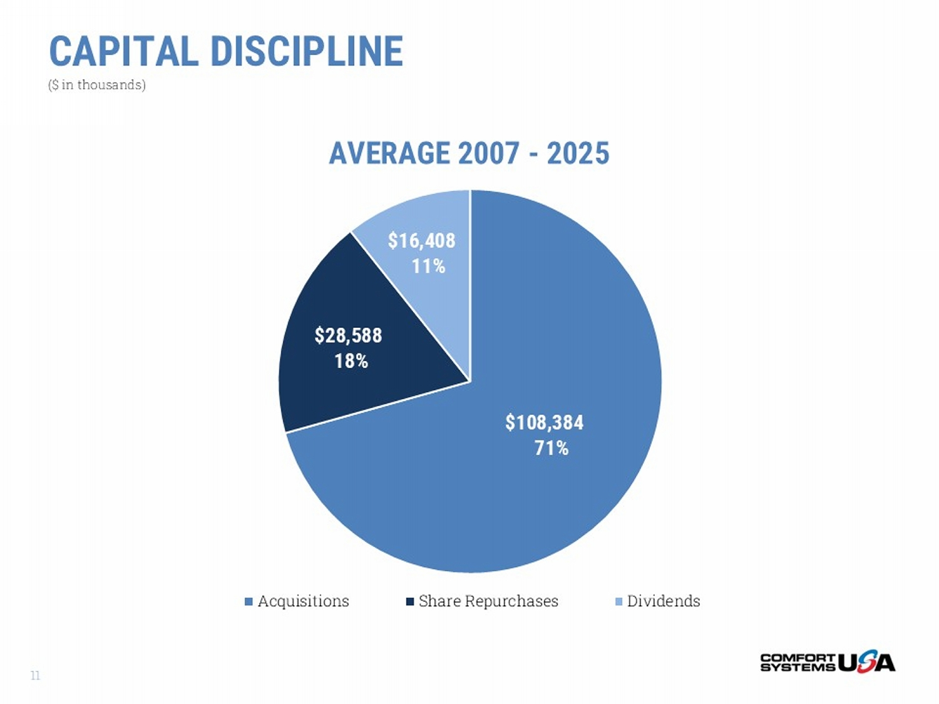
$108,384 71% $28,588 18% $16,408 11% AVERAGE 2007 - 2025 Acquisitions Share Repurchases Dividends CAPITAL DISCIPLINE ($ in thousands) 11

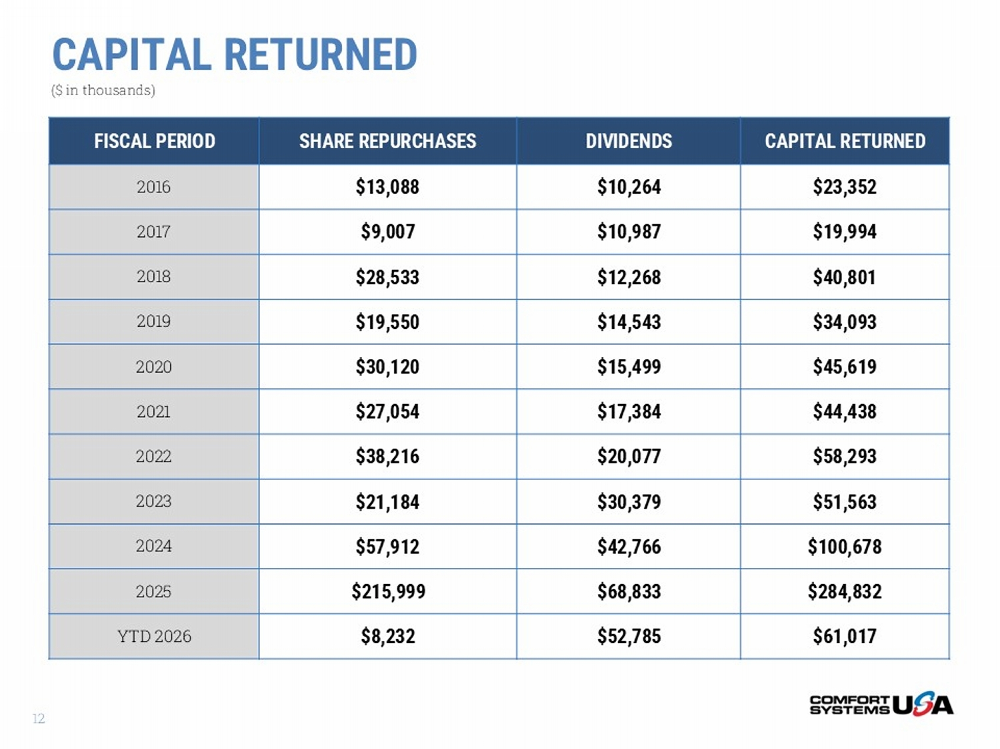
CAPITAL RETURNED ($ in thousands) CAPITAL RETURNED DIVIDENDS SHARE REPURCHASES FISCAL PERIOD $23,352 $10,264 $13,088 2016 $19,994 $10,987 $9,007 2017 $40,801 $12,268 $28,533 2018 $34,093 $14,543 $19,550 2019 $45,619 $15,499 $30,120 2020 $44,438 $17,384 $27,054 2021 $58,293 $20,077 $38,216 2022 $51,563 $30,379 $21,184 2023 $100,678 $42,766 $57,912 2024 $284,832 $68,833 $215,999 2025 $61,017 $52,785 $8,232 YTD 2026 12

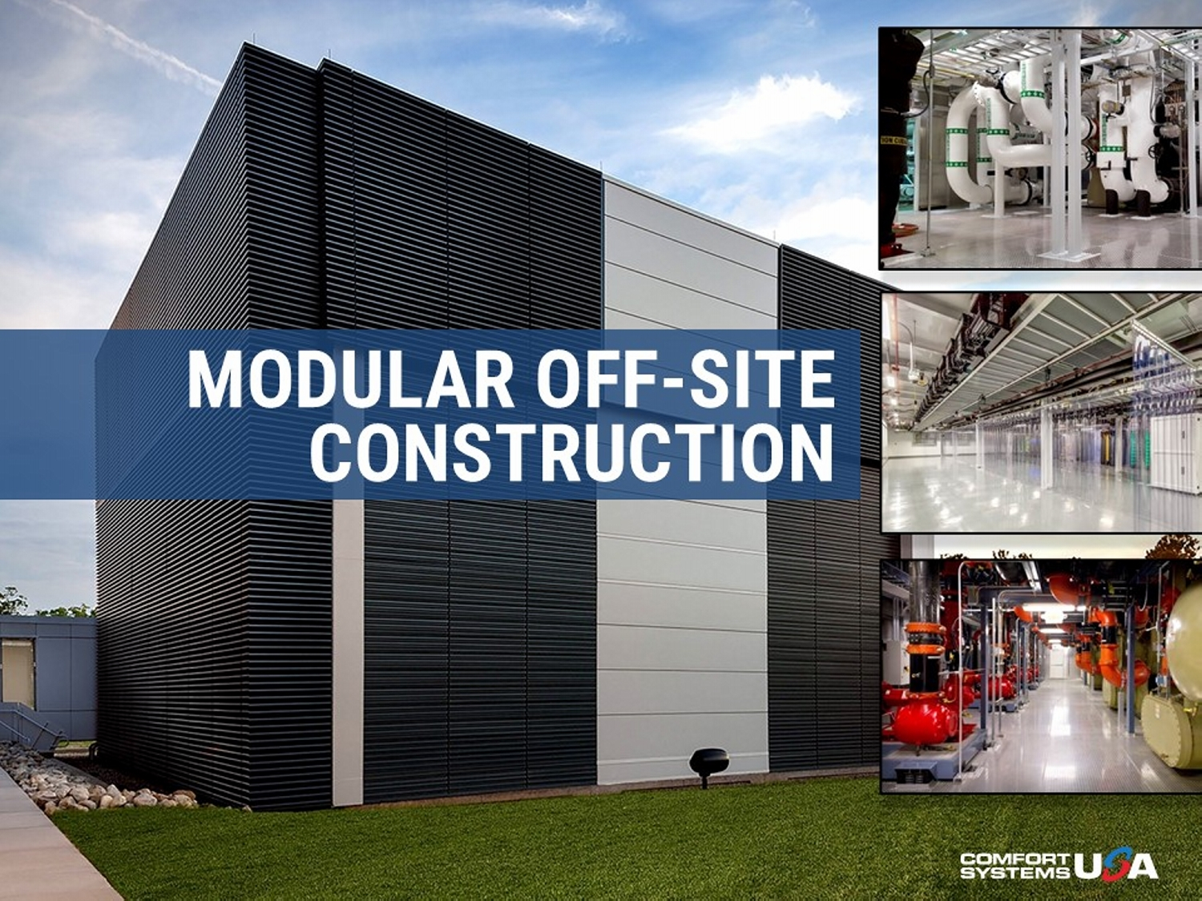
MODULAR OFF - SITE CONSTRUCTION

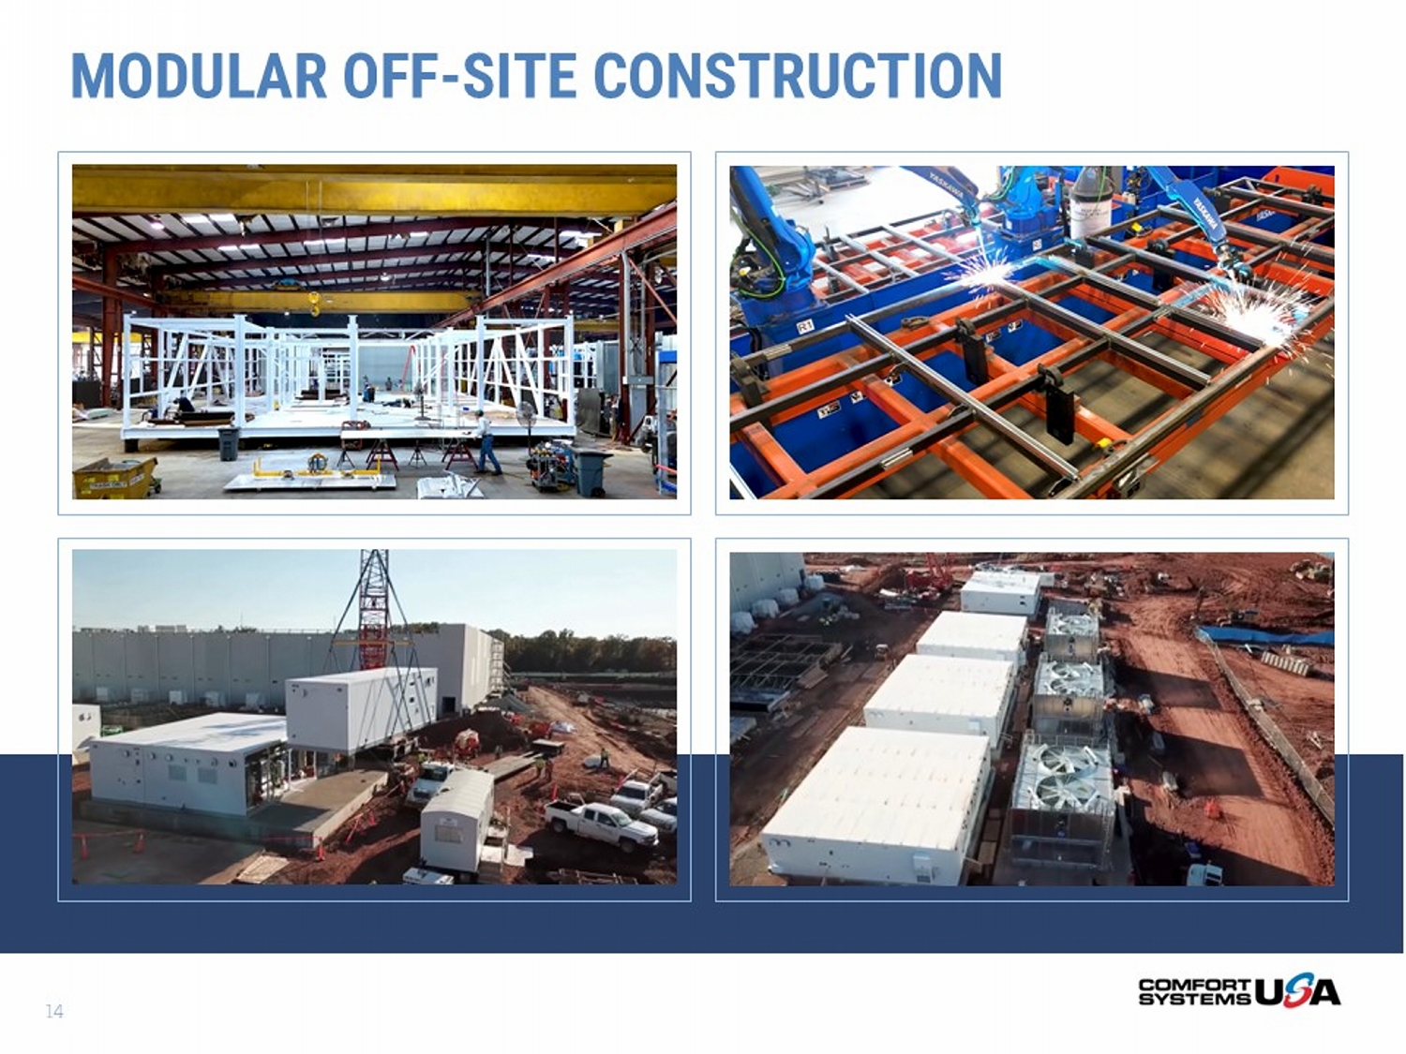
MODULAR OFF - SITE CONSTRUCTION 14

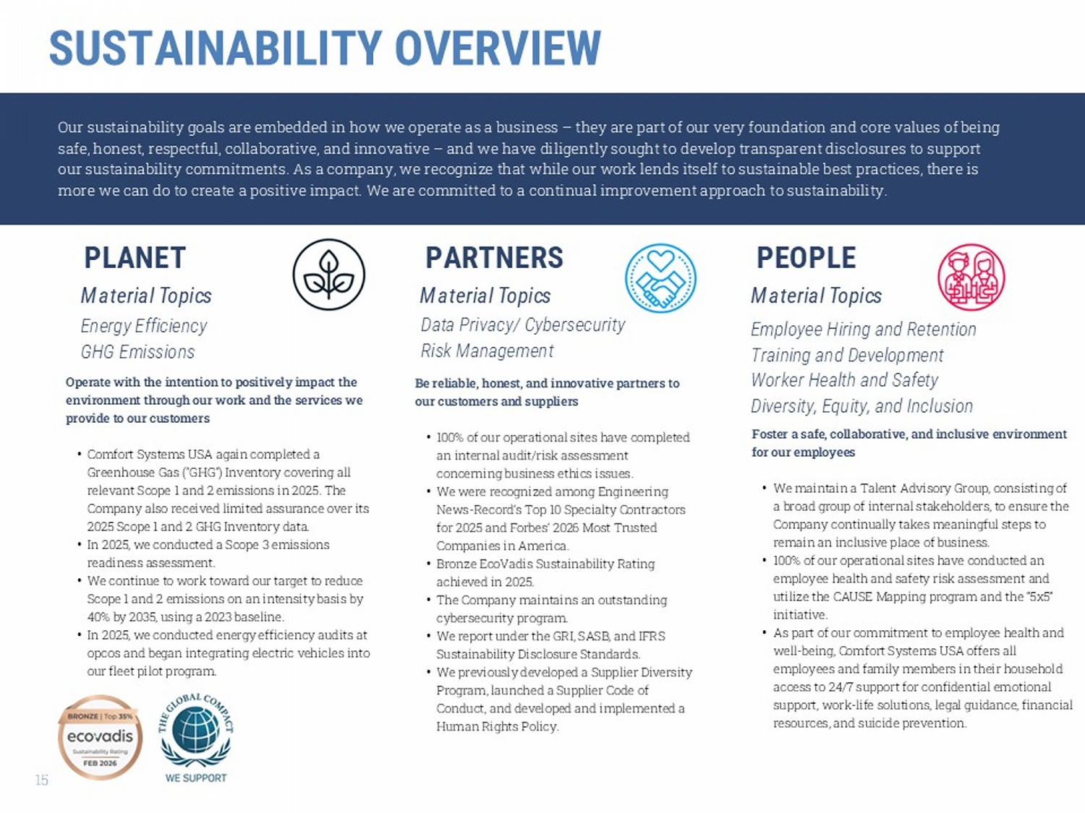
Foster a safe, collaborative, and inclusive environment for our employees • We maintain a Talent Advisory Group, consisting of a broad group of internal stakeholders, to ensure the Company continually takes meaningful steps to remain an inclusive place of business. • 100% of our operational sites have conducted an employee health and safety risk assessment and utilize the CAUSE Mapping program and the “5x5” initiative. • As part of our commitment to employee health and well - being, Comfort Systems USA offers all employees and family members in their household access to 24/7 support for confidential emotional support, work - life solutions, legal guidance, financial resources, and suicide prevention. Our sustainability goals are embedded in how we operate as a business – they are part of our very foundation and core values of being safe, honest, respectful, collaborative, and innovative – and we have diligently sought to develop transparent disclosures to su pport our sustainability commitments. As a company, we recognize that while our work lends itself to sustainable best practices, th ere is more we can do to create a positive impact. We are committed to a continual improvement approach to sustainability. PEOPLE PARTNERS PLANET Be reliable, honest, and innovative partners to our customers and suppliers • 100% of our operational sites have completed an internal audit/risk assessment concerning business ethics issues. • We were recognized among Engineering News - Record’s Top 10 Specialty Contractors for 2025 and Forbes’ 2026 Most Trusted Companies in America. • Bronze EcoVadis Sustainability Rating achieved in 2025. • The Company maintains an outstanding cybersecurity program. • We report under the GRI, SASB, and IFRS Sustainability Disclosure Standards. • We previously developed a Supplier Diversity Program, launched a Supplier Code of Conduct, and developed and implemented a Human Rights Policy. Operate with the intention to positively impact the environment through our work and the services we provide to our customers • Comfort Systems USA again completed a Greenhouse Gas ("GHG") Inventory covering all relevant Scope 1 and 2 emissions in 2025. The Company also received limited assurance over its 2025 Scope 1 and 2 GHG Inventory data. • In 2025, we conducted a Scope 3 emissions readiness assessment. • We continue to work toward our target to reduce Scope 1 and 2 emissions on an intensity basis by 40% by 2035, using a 2023 baseline. • In 2025, we conducted energy efficiency audits at opcos and began integrating electric vehicles into our fleet pilot program. Energy Efficiency GHG Emissions Data Privacy/ Cybersecurity Risk Management Employee Hiring and Retention Training and Development Worker Health and Safety Diversity, Equity, and Inclusion Material Topics Material Topics Material Topics SUSTAINABILITY OVERVIEW 15

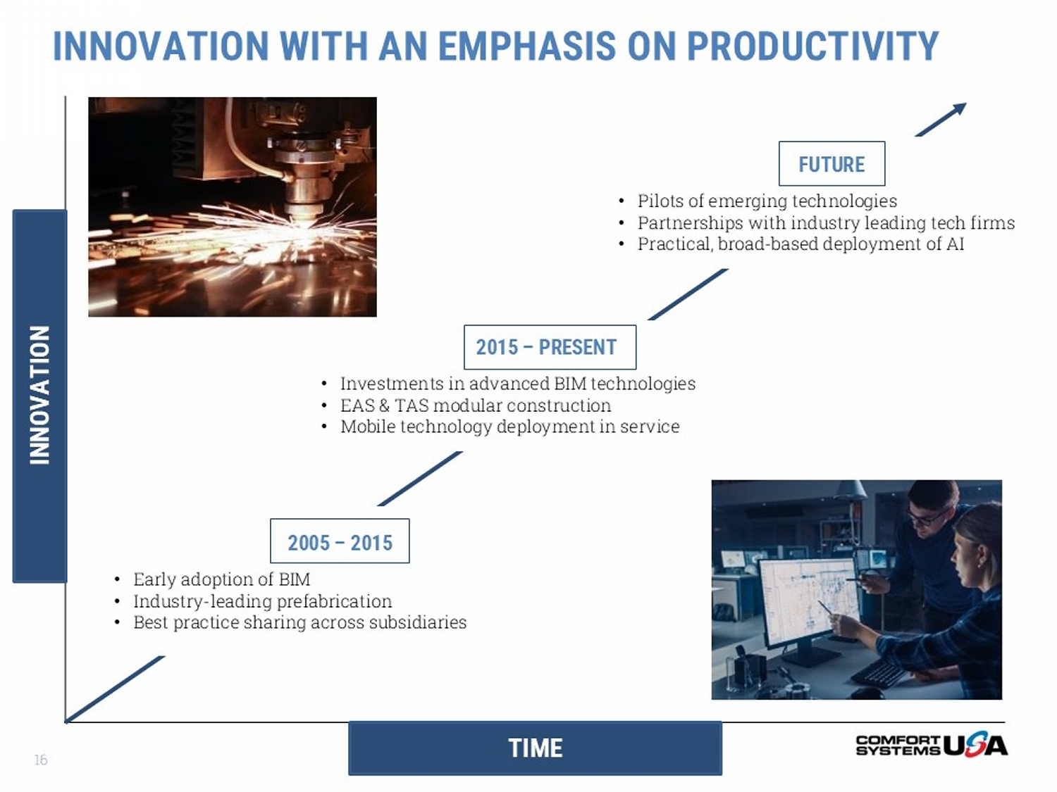
TIME INNOVATION INNOVATION WITH AN EMPHASIS ON PRODUCTIVITY 2005 – 2015 • Early adoption of BIM • Industry - leading prefabrication • Best practice sharing across subsidiaries 2015 – PRESENT • Investments in advanced BIM technologies • EAS & TAS modular construction • Mobile technology deployment in service FUTURE • Pilots of emerging technologies • Partnerships with industry leading tech firms • Practical, broad - based deployment of AI 16

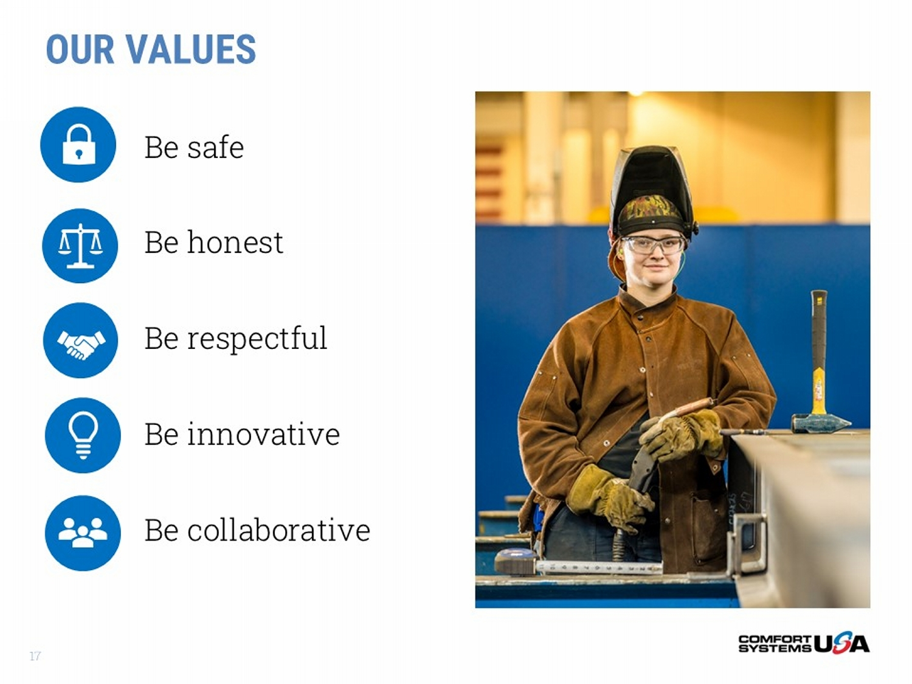
Be safe Be honest Be respectful Be innovative Be collaborative OUR VALUES 17

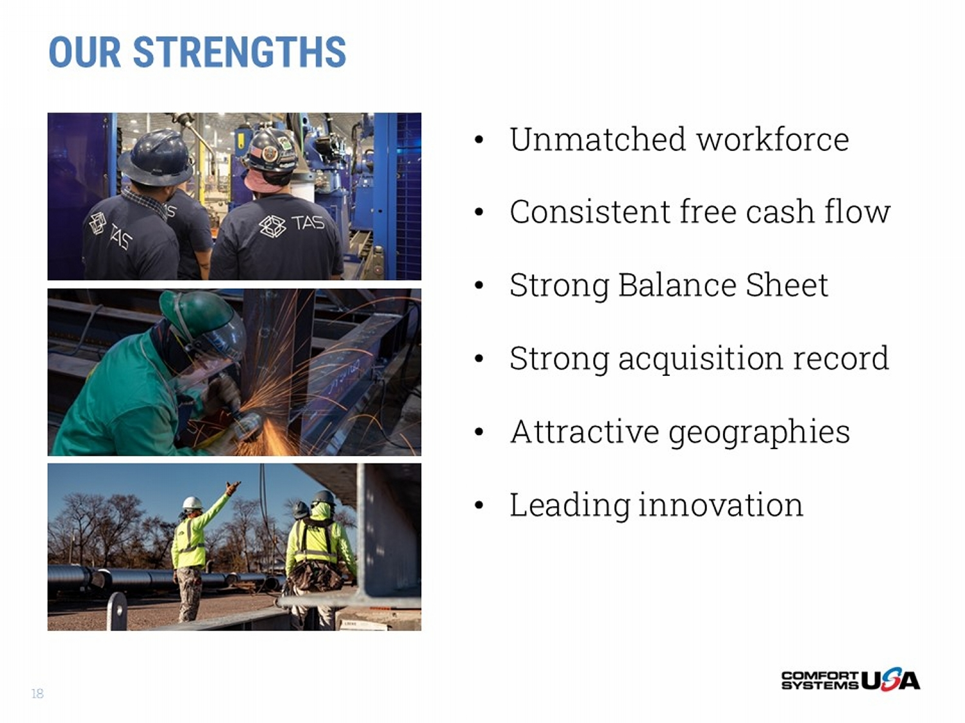
OUR STRENGTHS • Unmatched workforce • Consistent free cash flow • Strong Balance Sheet • Strong acquisition record • Attractive geographies • Leading innovation 18

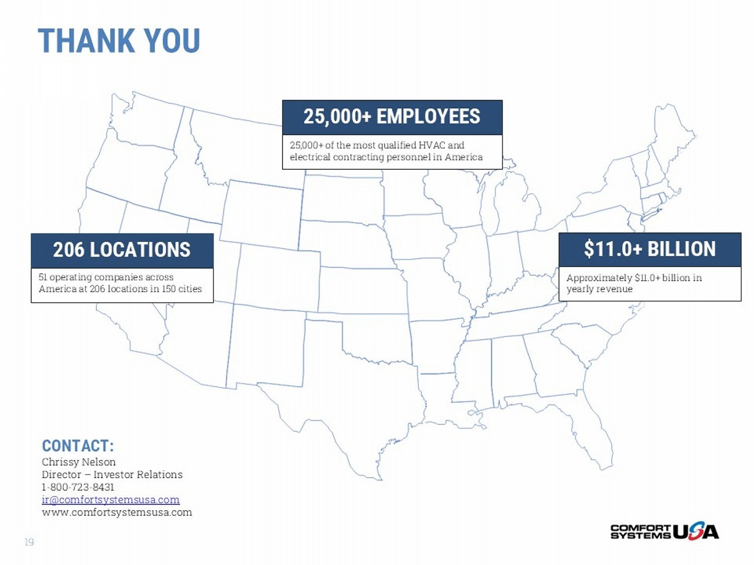
THANK YOU 206 LOCATIONS 51 operating companies across America at 206 locations in 150 cities 25,000+ of the most qualified HVAC and electrical contracting personnel in America 25,000+ EMPLOYEES $11.0+ BILLION Approximately $11.0+ billion in yearly revenue CONTACT: Chrissy Nelson Director – Investor Relations 1 - 800 - 723 - 8431 ir@comfortsystemsusa.com www.comfortsystemsusa.com 19

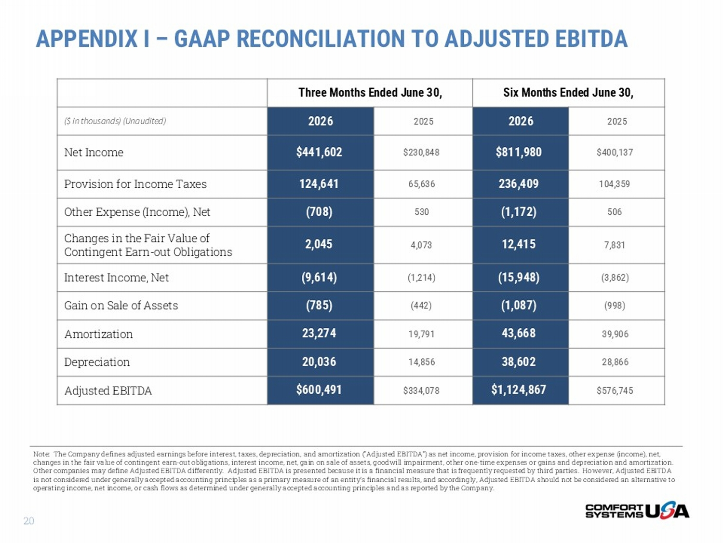
APPENDIX I – GAAP RECONCILIATION TO ADJUSTED EBITDA Six Months Ended June 30, Three Months Ended June 30, 2025 2026 2025 2026 ($ in thousands) (Unaudited) $400,137 $811,980 $230,848 $441,602 Net Income 104,359 236,409 65,636 124,641 Provision for Income Taxes 506 (1,172) 530 (708) Other Expense (Income), Net 7,831 12,415 4,073 2,045 Changes in the Fair Value of Contingent Earn - out Obligations (3,862) (15,948) (1,214) (9,614) Interest Income, Net (998) (1,087) (442) (785) Gain on Sale of Assets 39,906 43,668 19,791 23,274 Amortization 28,866 38,602 14,856 20,036 Depreciation $576,745 $1,124,867 $334,078 $600,491 Adjusted EBITDA Note: The Company defines adjusted earnings before interest, taxes, depreciation, and amortization (“Adjusted EBITDA”) as ne t i ncome, provision for income taxes, other expense (income), net, changes in the fair value of contingent earn - out obligations, interest income, net, gain on sale of assets, goodwill impairment, other one - time expenses or gains and depreciation and amortization. Other companies may define Adjusted EBITDA differently. Adjusted EBITDA is presented because it is a financial measure that is frequently requested by third parties. However, Adjusted EBITDA is not considered under generally accepted accounting principles as a primary measure of an entity’s financial results, and a cco rdingly, Adjusted EBITDA should not be considered an alternative to operating income, net income, or cash flows as determined under generally accepted accounting principles and as reported by t he Company. 20

