UNITED STATES
SECURITIES AND EXCHANGE COMMISSION
Washington, D.C. 20549

FORM 8-K

CURRENT REPORT
Pursuant to Section 13 OR 15(d) of The Securities Exchange Act of 1934

Date of Report (Date of earliest event reported) July 29, 2025

Comfort Systems USA, Inc.
(Exact name of registrant as specified in its charter)

Delaware |  | 1-13011 |  | 76-0526487
(State or other jurisdiction |  | (Commission |  | (IRS Employer
of incorporation) |  | File Number) |  | Identification No.)

675 Bering Drive, Suite 400
Houston, Texas |  | 77057
(Address of principal executive offices) |  | (Zip Code)

Registrant’s telephone number, including area code (713) 830-9600

(Former name or former address, if changed since last report.)

Check the appropriate box below if the Form 8-K filing is intended to simultaneously satisfy the filing obligation of the registrant under any of the following provisions:

☐ Written communications pursuant to Rule 425 under the Securities Act (17 CFR 230.425)
☐ Soliciting material pursuant to Rule 14a-12 under the Exchange Act (17 CFR 240.14a-12)
☐ Pre-commencement communications pursuant to Rule 14d-2(b) under the Exchange Act (17 CFR 240.14d-2(b))
☐ Pre-commencement communications pursuant to Rule 13e-4(c) under the Exchange Act (17 CFR 240.13e-4(c))

Securities registered pursuant to Section 12(b) of the Act:

Title of each class |  | Trading Symbol(s) |  | Name of each exchange on which registered
Common Stock, $0.01 par value |  | FIX |  | New York Stock Exchange

Indicate by check mark whether the registrant is an emerging growth company as defined in Rule 405 of the Securities Act of 1933 (§230.405 of this chapter) or Rule 12b-2 of the Securities Exchange Act of 1934 (§240.12b-2 of this chapter).

Emerging growth company ☐

If an emerging growth company, indicate by check mark if the registrant has elected not to use the extended transition period for complying with any new or revised financial accounting standards provided pursuant to Section 13(a) of the Exchange Act. ☐

ITEM 7.01 | Regulation FD Disclosure

On July 29, 2025, Comfort Systems USA, Inc., a Delaware corporation (the “Company”), a leading provider of commercial, industrial and institutional heating, ventilation, air conditioning and electrical contracting services, posted to the “Investor” section of its Internet website (www.comfortsystemsusa.com) an investor presentation slideshow. The Company intends to use this slideshow in making presentations to analysts, potential investors, and other interested parties.

The information included in the investor presentation includes financial information determined by methods other than in accordance with accounting principles generally accepted in the United States of America (“GAAP”). The Company’s management uses these non-GAAP measures in its analysis of the Company’s performance. The Company believes that the presentation of certain non-GAAP measures provides useful supplemental information that is essential to a proper understanding of the operating results of the Company’s core businesses. These non-GAAP disclosures should not be viewed as a substitute for operating results determined in accordance with GAAP, nor are they necessarily comparable to non-GAAP performance measures that may be presented by other companies.

The information in this Form 8-K being furnished under Item 7.01 shall not be deemed to be “filed” for the purposes of Section 18 of the Securities Exchange Act of 1934, as amended (the “Exchange Act”), or otherwise subject to the liabilities of such section, nor shall such information be deemed incorporated by reference in any filing under the Securities Act of 1933, as amended, or the Exchange Act, except as shall be expressly set forth by specific reference in such a filing. The investor presentation contains forward-looking statements within the meaning of applicable securities laws and regulations. These statements are based on the Company’s expectations and involve risks and uncertainties that could cause the Company’s actual results to differ materially from those set forth in the statements. These risks are discussed in the Company’s filings with the Securities and Exchange Commission, including an extensive discussion of these risks in the Company’s Annual Report on Form 10-K for the year ended December 31, 2024.

A copy of the presentation is furnished herewith as Exhibit 99.1.

ITEM 9.01 | Financial Statements and Exhibits

(d) Exhibits.

Exhibit  Number |  | Description
99.1 |  | Investor presentation dated July 29, 2025
104 |  | Cover Page Interactive Data File (the cover page XBRL tags are embedded within the Inline XBRL document).

SIGNATURES

Pursuant to the requirements of the Securities Exchange Act of 1934, the Registrant has duly caused this report to be signed on its behalf by the undersigned hereunto duly authorized.

 |  | COMFORT SYSTEMS USA, INC.
 | By: | /s/ Laura F. Howell
 |  | Laura F. Howell
 |  | Senior Vice President and General Counsel
Date: July 29, 2025

Exhibit 99.1

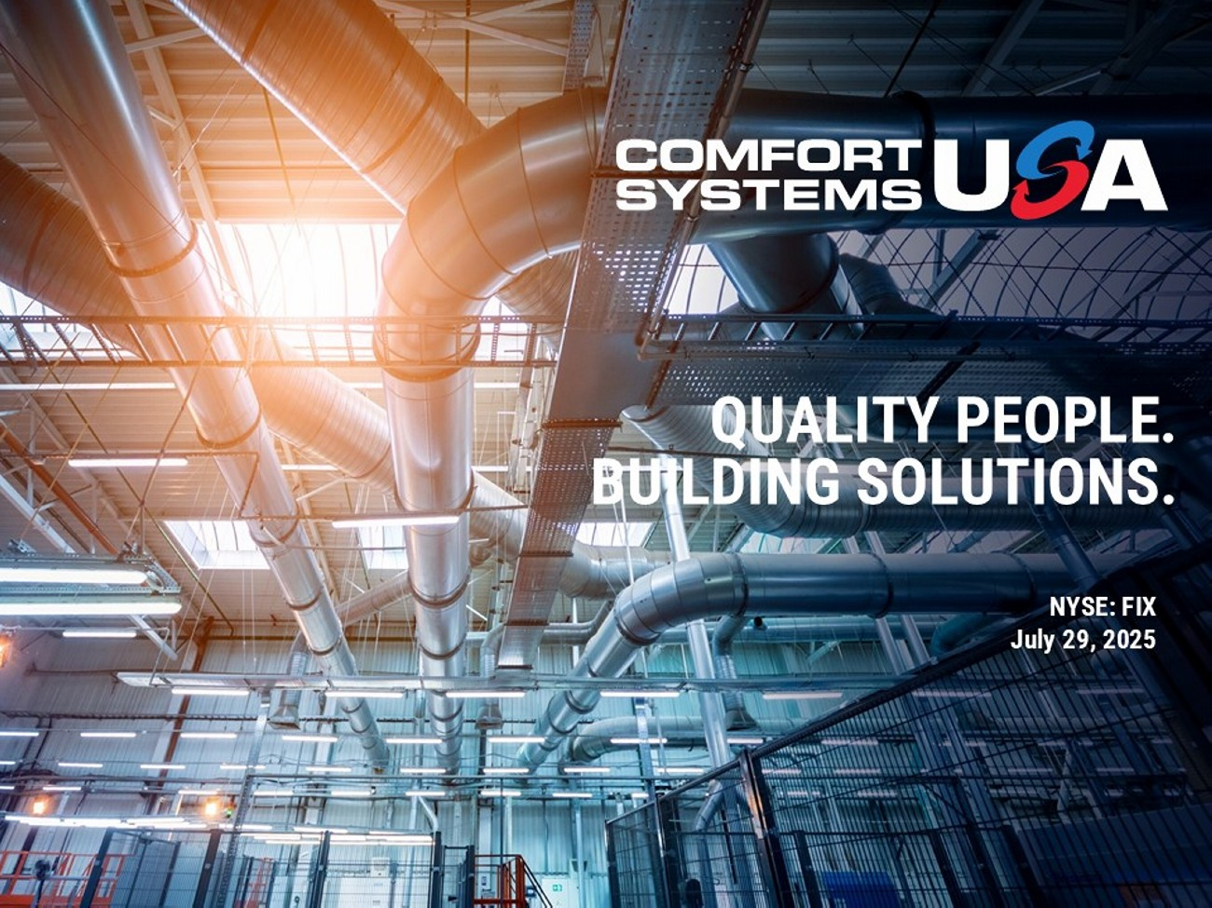
QUALITY PEOPLE. BUILDING SOLUTIONS. NYSE: FIX July 29, 2025

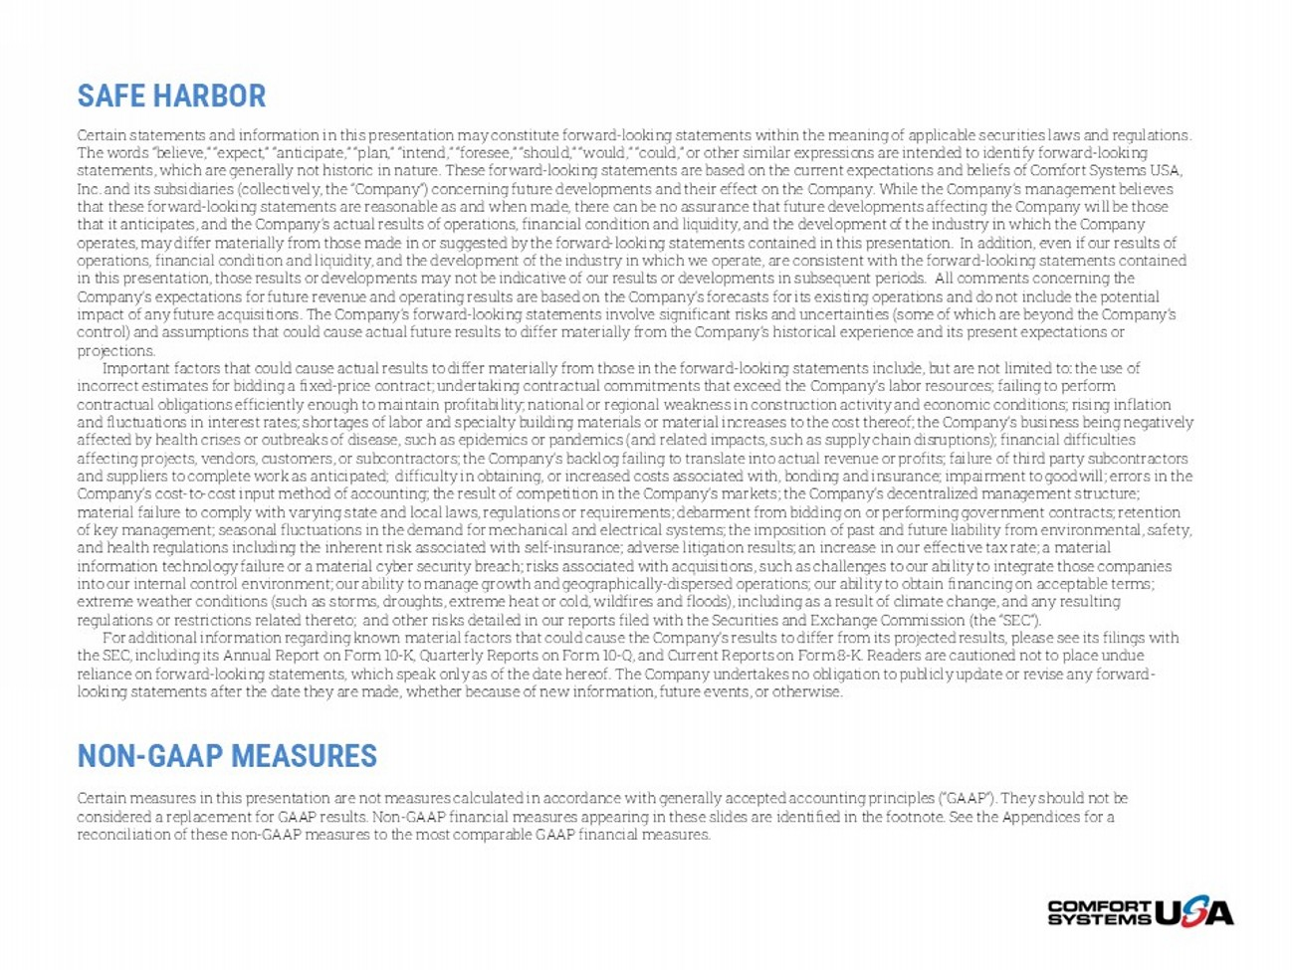
SAFE HARBOR Certain statements and information in this presentation may constitute forward - looking statements within the meaning of applicab le securities laws and regulations. The words “believe,” “expect,” “anticipate,” “plan,” “intend,” “foresee,” “should,” “would,” “could,” or other similar expres sio ns are intended to identify forward - looking statements, which are generally not historic in nature. These forward - looking statements are based on the current expectations a nd beliefs of Comfort Systems USA, Inc. and its subsidiaries (collectively, the “Company”) concerning future developments and their effect on the Company. While th e Company’s management believes that these forward - looking statements are reasonable as and when made, there can be no assurance that future developments affect ing the Company will be those that it anticipates, and the Company’s actual results of operations, financial condition and liquidity, and the development o f t he industry in which the Company operates, may differ materially from those made in or suggested by the forward - looking statements contained in this presentation . In addition, even if our results of operations, financial condition and liquidity, and the development of the industry in which we operate, are consistent with t he forward - looking statements contained in this presentation, those results or developments may not be indicative of our results or developments in subsequent period s. All comments concerning the Company’s expectations for future revenue and operating results are based on the Company’s forecasts for its existing operati ons and do not include the potential impact of any future acquisitions. The Company’s forward - looking statements involve significant risks and uncertainties (some of which are beyond the Company’s control) and assumptions that could cause actual future results to differ materially from the Company’s historical experience an d its present expectations or projections. Important factors that could cause actual results to differ materially from those in the forward - looking statements include, but are not limited to: the use of incorrect estimates for bidding a fixed - price contract; undertaking contractual commitments that exceed the Company’s labor reso urces; failing to perform contractual obligations efficiently enough to maintain profitability; national or regional weakness in construction activity and economic conditions; rising inflation and fluctuations in interest rates; shortages of labor and specialty building materials or material increases to the cost the reo f; the Company’s business being negatively affected by health crises or outbreaks of disease, such as epidemics or pandemics (and related impacts, such as supply chain dis ruptions); financial difficulties affecting projects, vendors, customers, or subcontractors; the Company’s backlog failing to translate into actual revenue or pro fits; failure of third party subcontractors and suppliers to complete work as anticipated; difficulty in obtaining, or increased costs associated with, bonding and insu ran ce; impairment to goodwill; errors in the Company’s cost - to - cost input method of accounting; the result of competition in the Company’s markets; the Company’s decentraliz ed management structure; material failure to comply with varying state and local laws, regulations or requirements; debarment from bidding on or perfo rmi ng government contracts; retention of key management; seasonal fluctuations in the demand for mechanical and electrical systems; the imposition of past and futu re liability from environmental, safety, and health regulations including the inherent risk associated with self - insurance; adverse litigation results; an increase in ou r effective tax rate; a material information technology failure or a material cyber security breach; risks associated with acquisitions, such as challenges to ou r ability to integrate those companies into our internal control environment; our ability to manage growth and geographically - dispersed operations; our ability to obta in financing on acceptable terms; extreme weather conditions (such as storms, droughts, extreme heat or cold, wildfires and floods), including as a result of c lim ate change, and any resulting regulations or restrictions related thereto; and other risks detailed in our reports filed with the Securities and Exchange Com mission (the “SEC”). For additional information regarding known material factors that could cause the Company’s results to differ from its project ed results, please see its filings with the SEC, including its Annual Report on Form 10 - K, Quarterly Reports on Form 10 - Q, and Current Reports on Form 8 - K. Readers are cautioned not to place undue reliance on forward - looking statements, which speak only as of the date hereof. The Company undertakes no obligation to publicly update or revise any forward - looking statements after the date they are made, whether because of new information, future events, or otherwise. NON - GAAP MEASURES Certain measures in this presentation are not measures calculated in accordance with generally accepted accounting principles (“ GAAP”). They should not be considered a replacement for GAAP results. Non - GAAP financial measures appearing in these slides are identified in the footnote. See the Appendices for a reconciliation of these non - GAAP measures to the most comparable GAAP financial measures.

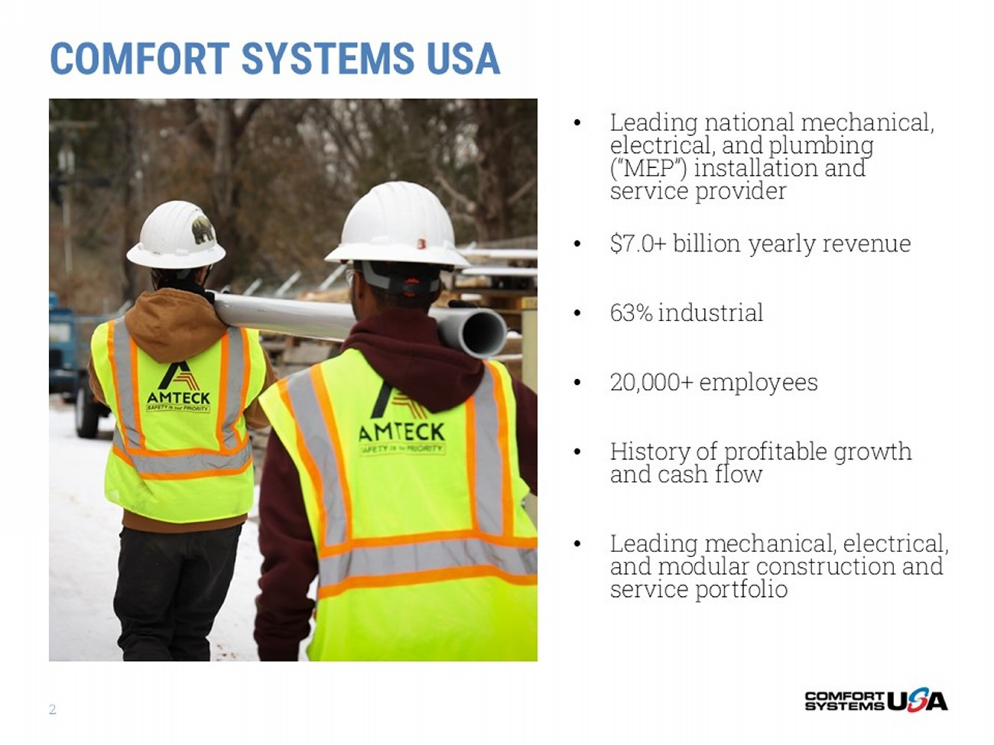
2 • Leading national mechanical, electrical, and plumbing (“MEP”) installation and service provider • $7.0+ billion yearly revenue • 63% industrial • 20,000+ employees • History of profitable growth and cash flow • Leading mechanical, electrical, and modular construction and service portfolio COMFORT SYSTEMS USA

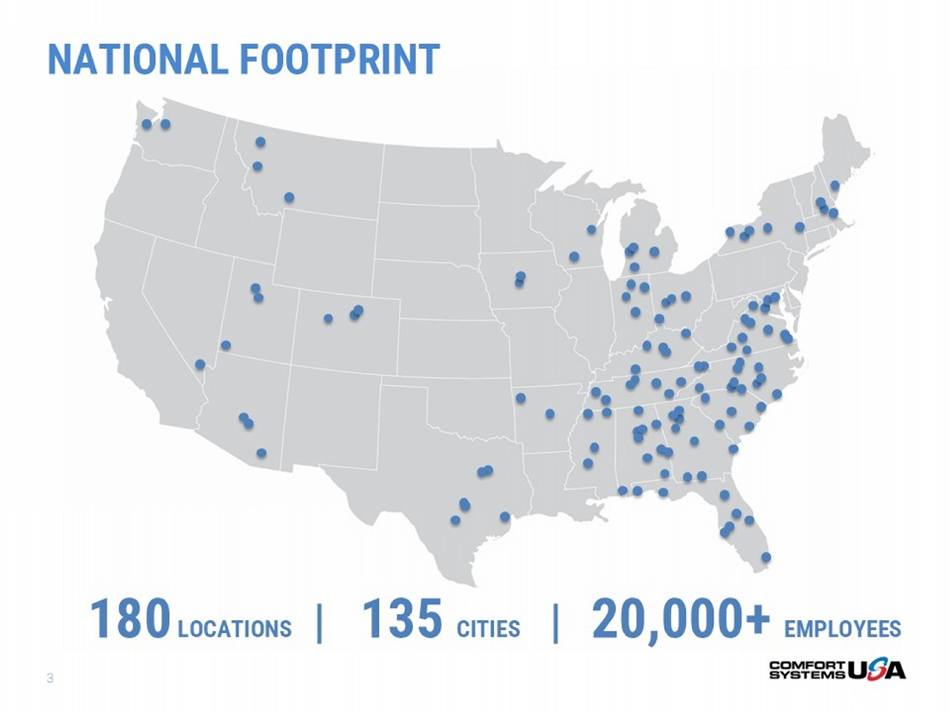
3 180 LOCATIONS | 13 5 CITIES | 20 ,000+ EMPLOYEES NATIONAL FOOTPRINT

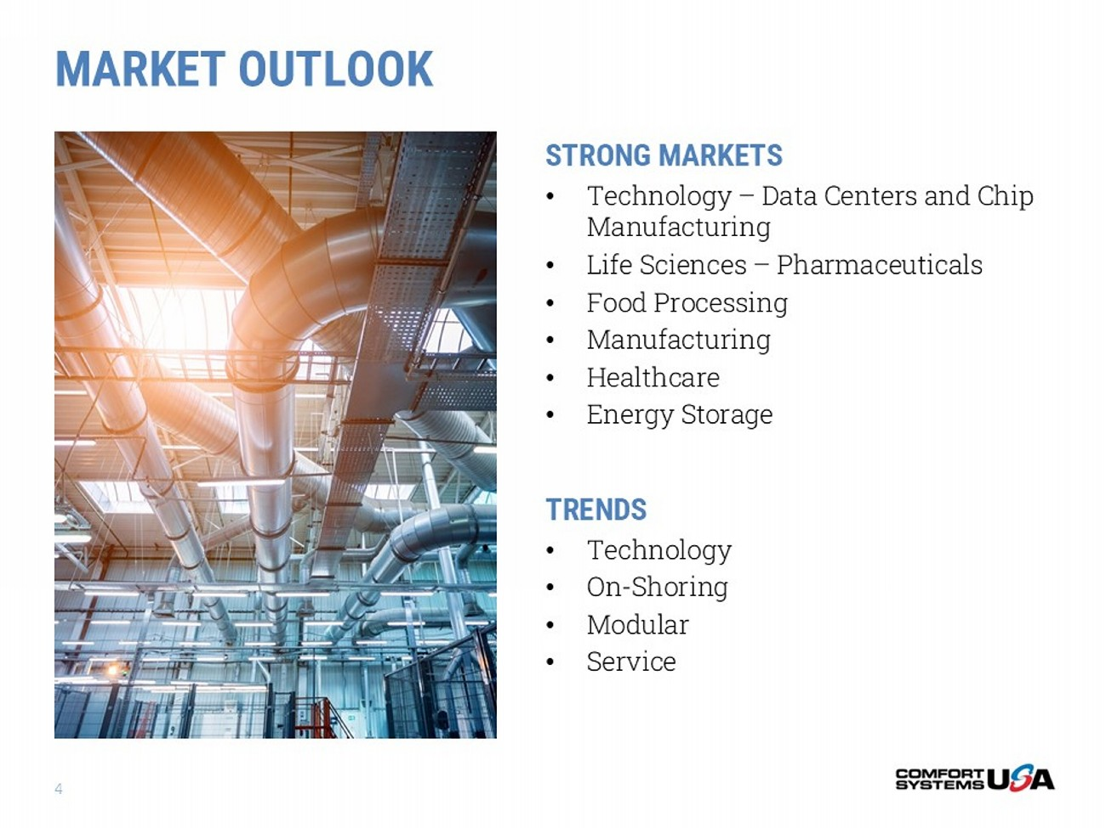
MARKET OUTLOOK 4 STRONG MARKETS • Technology – Data Centers and Chip Manufacturing • Life Sciences – Pharmaceuticals • Food Processing • Manufacturing • Healthcare • Energy Storage TRENDS • Technology • On - Shoring • Modular • Service

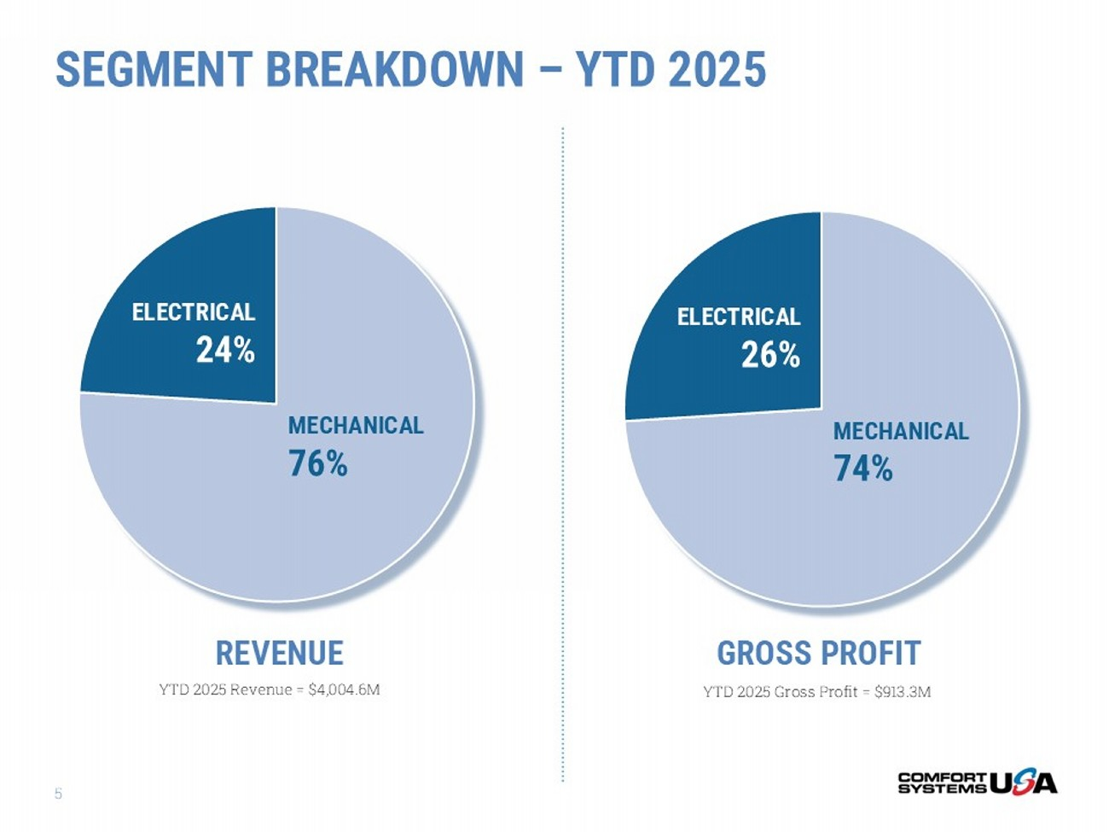
5 REVENUE GROSS PROFIT YTD 2025 Gross Profit = $913.3M YTD 2025 Revenue = $4,004.6M SEGMENT BREAKDOWN – YTD 2025 MECHANICAL 76% ELECTRICAL 24% MECHANICAL 74% ELECTRICAL 26%

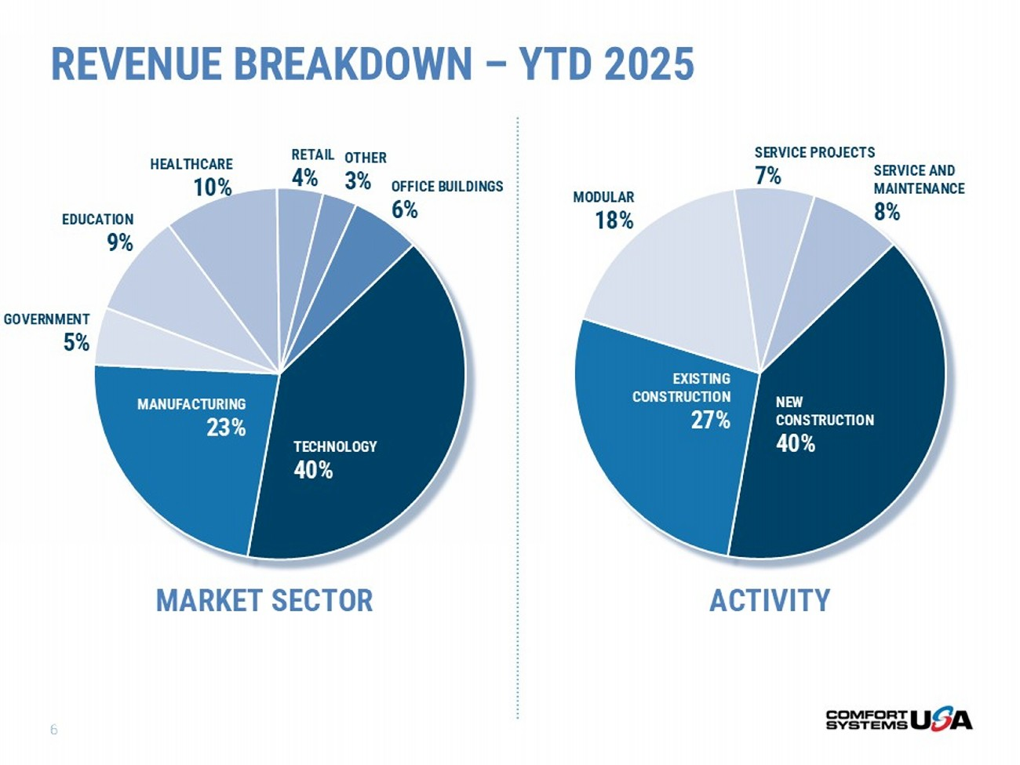
6 MARKET SECTOR ACTIVITY REVENUE BREAKDOWN – YTD 2025 TECHNOLOGY 40% MANUFACTURING 23% GOVERNMENT 5% EDUCATION 9% HEALTHCARE 10% RETAIL 4% OTHER 3% OFFICE BUILDINGS 6% NEW CONSTRUCTION 40% EXISTING CONSTRUCTION 27% MODULAR 18% SERVICE PROJECTS 7% SERVICE AND MAINTENANCE 8%

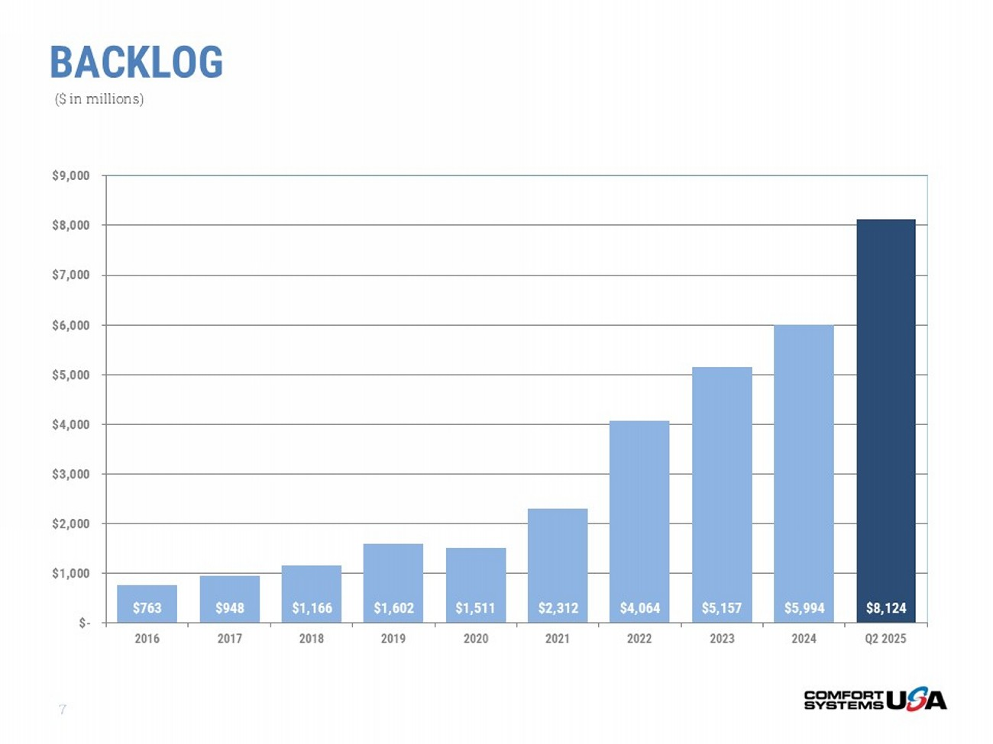
BACKLOG 7 $763 $948 $1,166 $1,602 $1,511 $2,312 $4,064 $5,157 $5,994 $8,124 $- $1,000 $2,000 $3,000 $4,000 $5,000 $6,000 $7,000 $8,000 $9,000 2016 2017 2018 2019 2020 2021 2022 2023 2024 Q2 2025 ($ in millions)

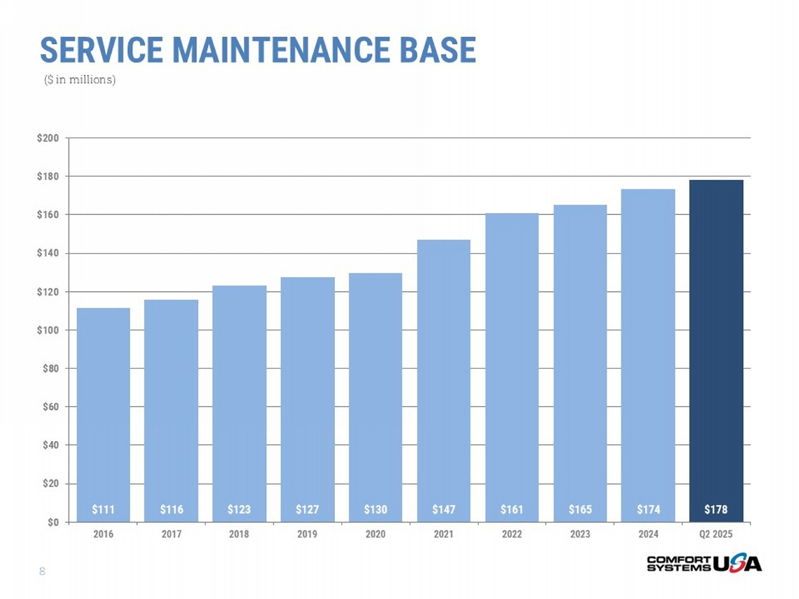
8 $111 $116 $123 $127 $130 $147 $161 $165 $174 $178 $0 $20 $40 $60 $80 $100 $120 $140 $160 $180 $200 2016 2017 2018 2019 2020 2021 2022 2023 2024 Q2 2025 SERVICE MAINTENANCE BASE ($ in millions)

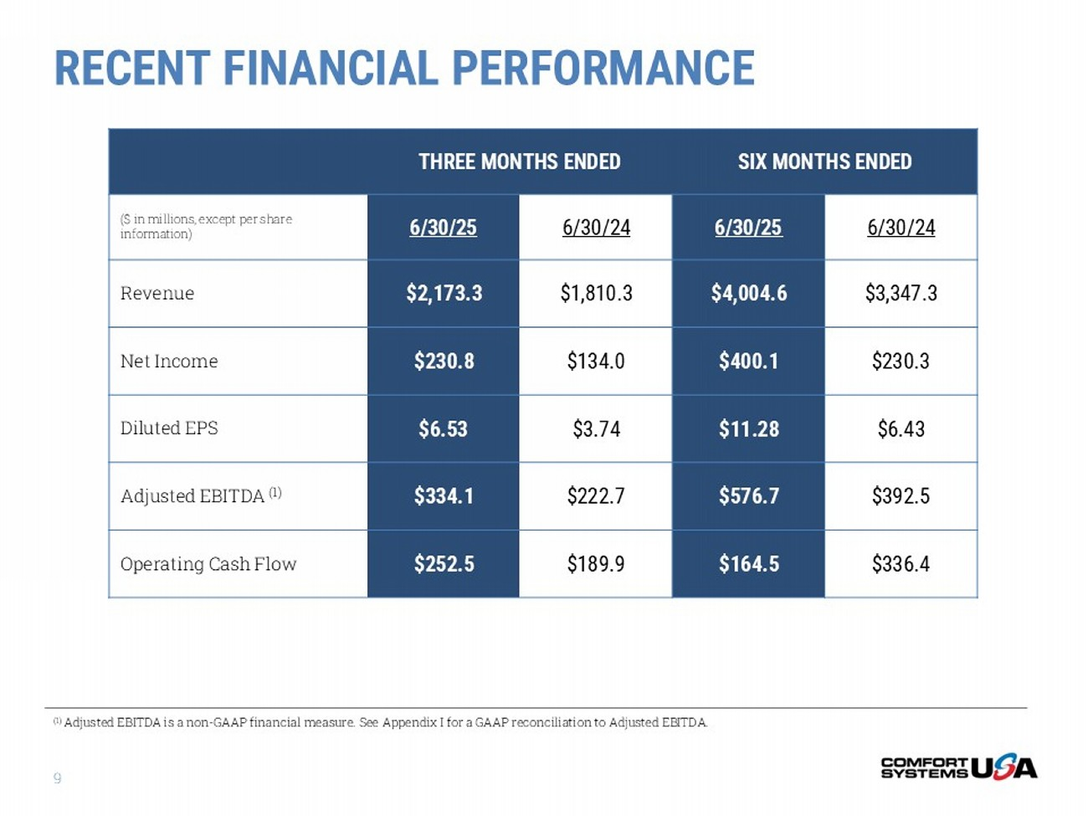
9 SIX MONTHS ENDED THREE MONTHS ENDED 6/30/24 6/30/25 6/30/24 6/30/25 ($ in millions, except per share information) $3,347.3 $4,004.6 $1,810.3 $2,173.3 Revenue $230.3 $400.1 $134.0 $230.8 Net Income $6.43 $11.28 $3.74 $6.53 Diluted EPS $392.5 $576.7 $222.7 $334.1 Adjusted EBITDA (1) $336.4 $164.5 $189.9 $252.5 Operating Cash Flow (1) Adjusted EBITDA is a non - GAAP financial measure. See Appendix I for a GAAP reconciliation to Adjusted EBITDA. RECENT FINANCIAL PERFORMANCE

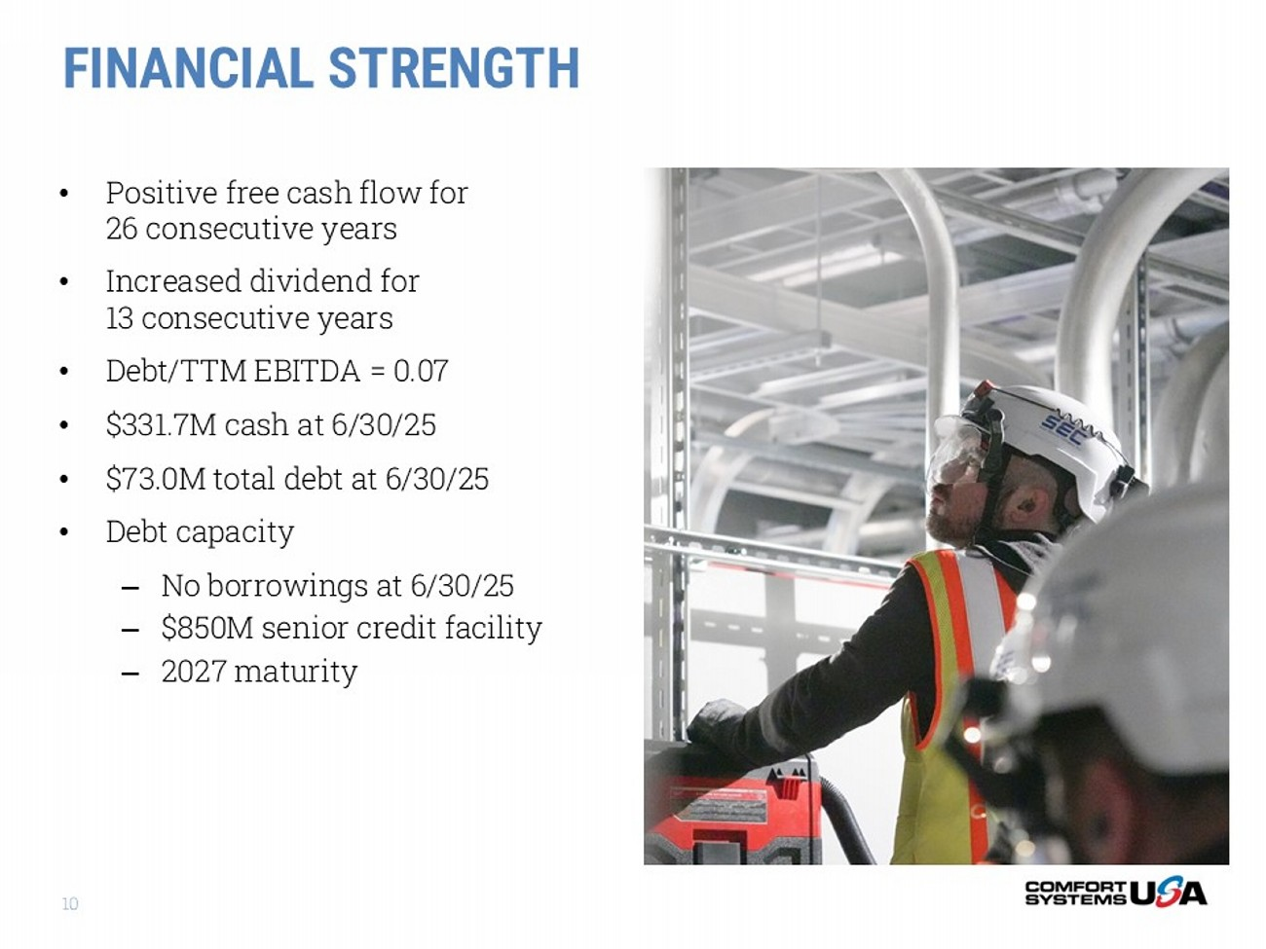
FINANCIAL STRENGTH • Positive free cash flow for 26 consecutive years • Increased dividend for 13 consecutive years • Debt/TTM EBITDA = 0.07 • $331.7M cash at 6/30/25 • $73.0M total debt at 6/30/25 • Debt capacity – No borrowings at 6/30/25 – $850M senior credit facility – 2027 maturity 10

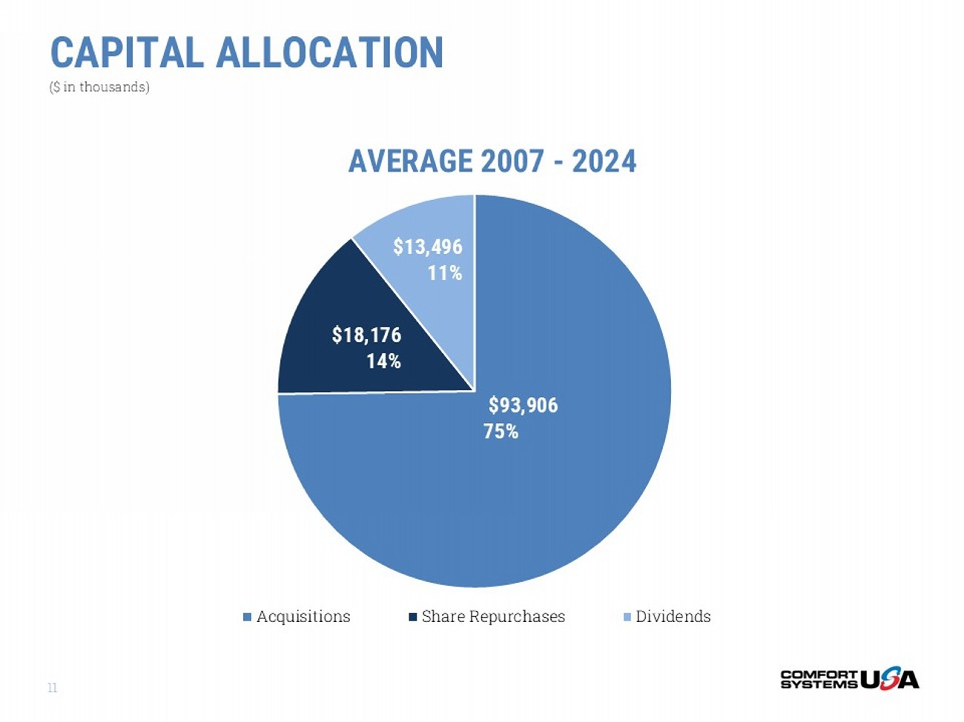
11 $93,906 75% $18,176 14% $13,496 11% AVERAGE 2007 - 2024 Acquisitions Share Repurchases Dividends CAPITAL ALLOCATION ($ in thousands)

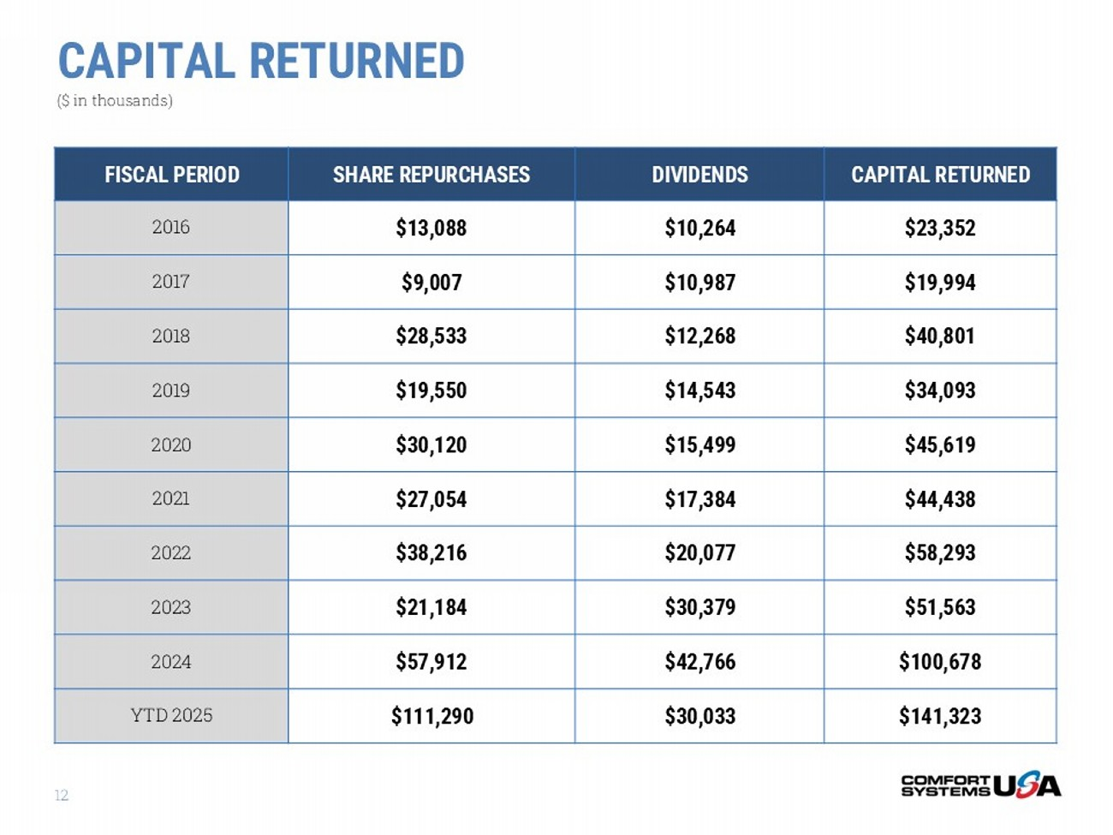
12 CAPITAL RETURNED ($ in thousands) CAPITAL RETURNED DIVIDENDS SHARE REPURCHASES FISCAL PERIOD $23,352 $10,264 $13,088 2016 $19,994 $10,987 $9,007 2017 $40,801 $12,268 $28,533 2018 $34,093 $14,543 $19,550 2019 $45,619 $15,499 $30,120 2020 $44,438 $17,384 $27,054 2021 $58,293 $20,077 $38,216 2022 $51,563 $30,379 $21,184 2023 $100,678 $42,766 $57,912 2024 $141,323 $30,033 $111,290 YTD 2025

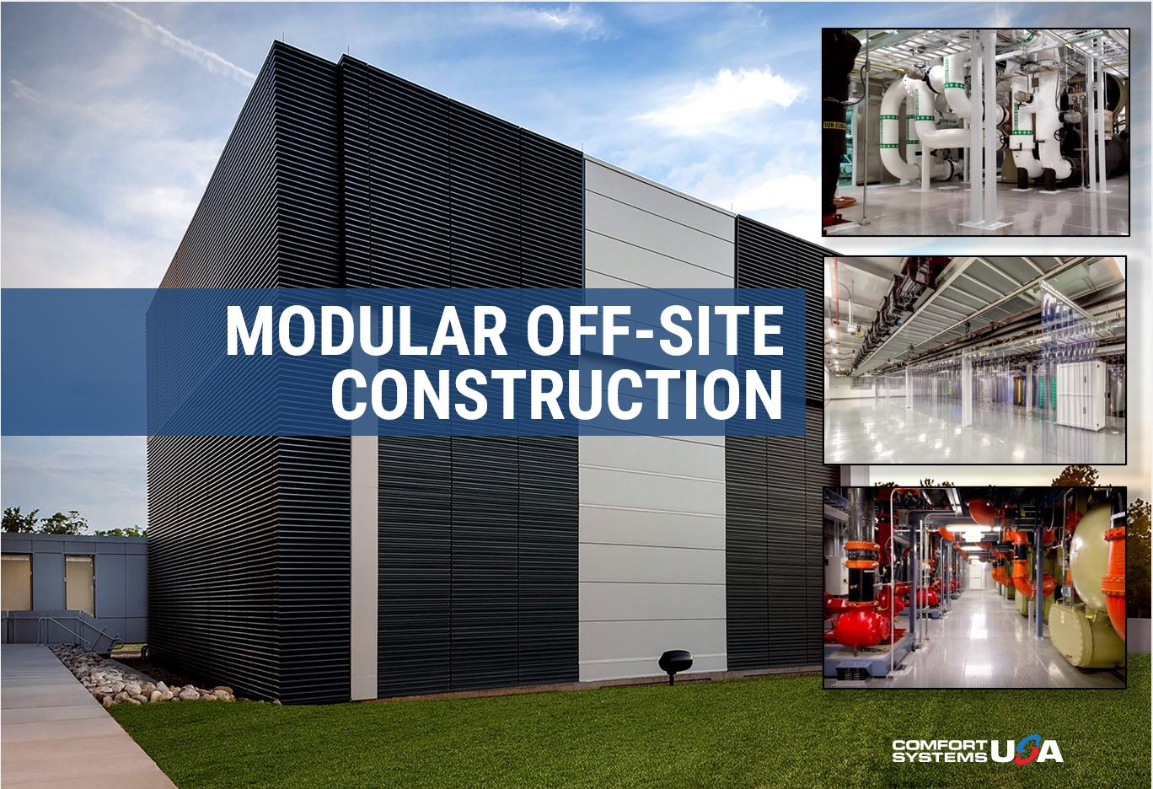
MODULAR OFF - SITE CONSTRUCTION

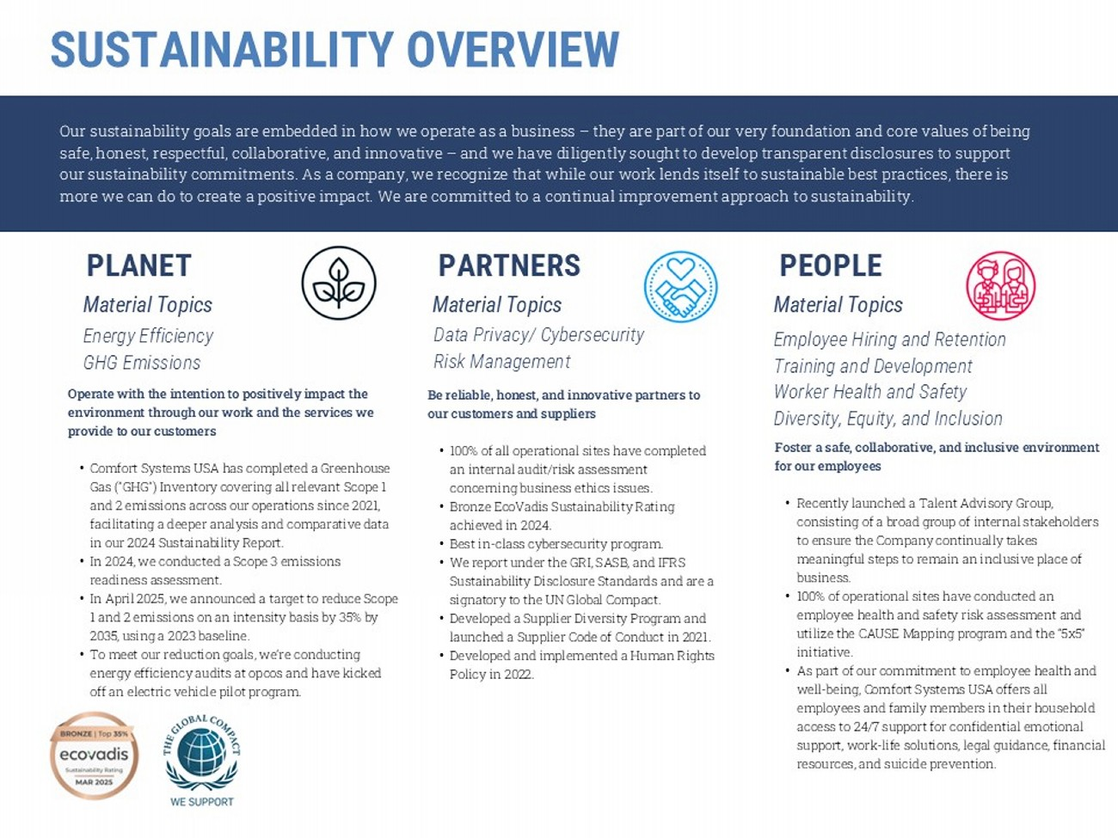
Foster a safe, collaborative, and inclusive environment for our employees • Recently launched a Talent Advisory Group, consisting of a broad group of internal stakeholders to ensure the Company continually takes meaningful steps to remain an inclusive place of business. • 100% of operational sites have conducted an employee health and safety risk assessment and utilize the CAUSE Mapping program and the “5x5” initiative. • As part of our commitment to employee health and well - being, Comfort Systems USA offers all employees and family members in their household access to 24/7 support for confidential emotional support, work - life solutions, legal guidance, financial resources, and suicide prevention. Our sustainability goals are embedded in how we operate as a business – they are part of our very foundation and core values of being safe, honest, respectful, collaborative, and innovative – and we have diligently sought to develop transparent disclosures to su pport our sustainability commitments. As a company, we recognize that while our work lends itself to sustainable best practices, th ere is more we can do to create a positive impact. We are committed to a continual improvement approach to sustainability. PEOPLE PARTNERS PLANET Be reliable, honest, and innovative partners to our customers and suppliers • 100% of all operational sites have completed an internal audit/risk assessment concerning business ethics issues. • Bronze EcoVadis Sustainability Rating achieved in 2024. • Best in - class cybersecurity program. • We report under the GRI, SASB, and IFRS Sustainability Disclosure Standards and are a signatory to the UN Global Compact. • Developed a Supplier Diversity Program and launched a Supplier Code of Conduct in 2021. • Developed and implemented a Human Rights Policy in 2022. Operate with the intention to positively impact the environment through our work and the services we provide to our customers • Comfort Systems USA has completed a Greenhouse Gas ("GHG") Inventory covering all relevant Scope 1 and 2 emissions across our operations since 2021, facilitating a deeper analysis and comparative data in our 2024 Sustainability Report. • In 2024, we conducted a Scope 3 emissions readiness assessment. • In April 2025, we announced a target to reduce Scope 1 and 2 emissions on an intensity basis by 35% by 2035, using a 2023 baseline. • To meet our reduction goals, we’re conducting energy efficiency audits at opcos and have kicked off an electric vehicle pilot program. Energy Efficiency GHG Emissions Data Privacy/ Cybersecurity Risk Management Employee Hiring and Retention Training and Development Worker Health and Safety Diversity, Equity, and Inclusion Material Topics Material Topics Material Topics SUSTAINABILITY OVERVIEW 14

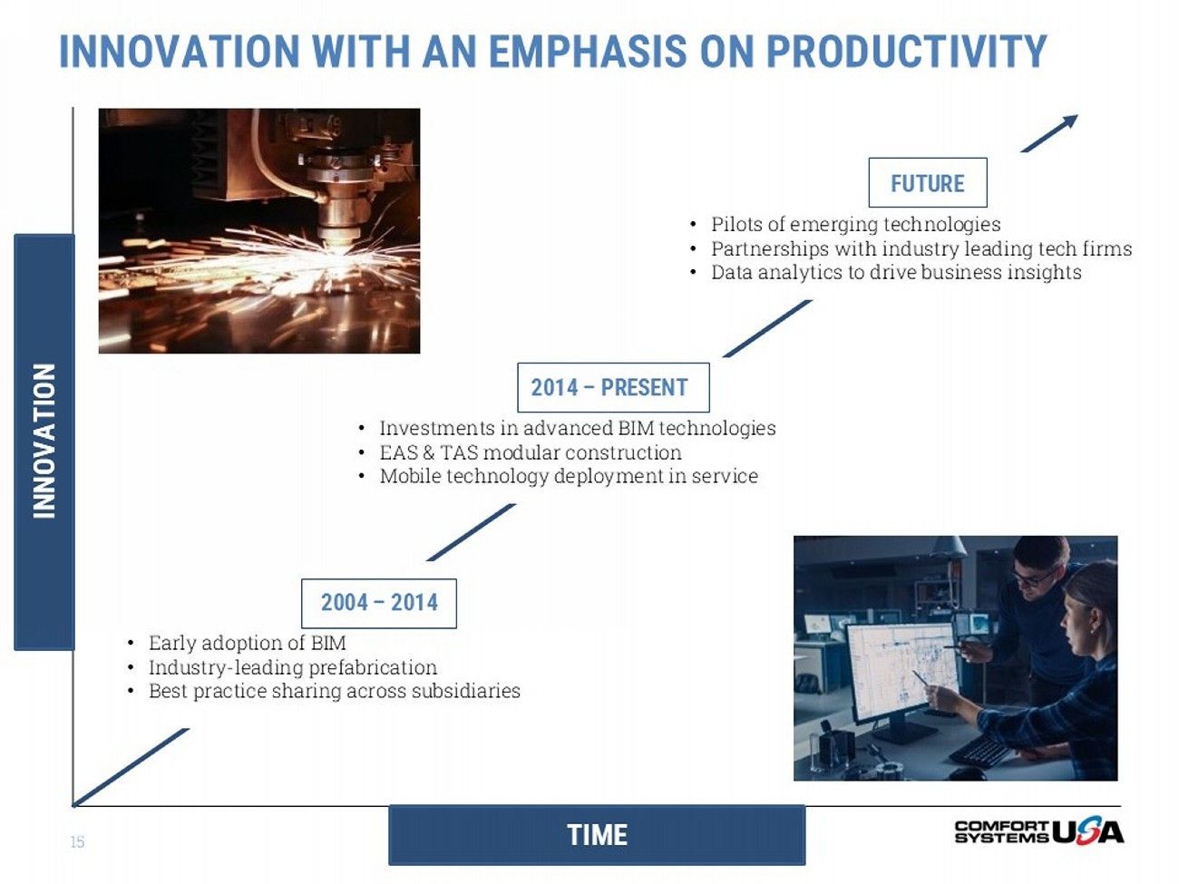
TIME INNOVATION INNOVATION WITH AN EMPHASIS ON PRODUCTIVITY 2004 – 2014 • Early adoption of BIM • Industry - leading prefabrication • Best practice sharing across subsidiaries 2014 – PRESENT • Investments in advanced BIM technologies • EAS & TAS modular construction • Mobile technology deployment in service FUTURE • Pilots of emerging technologies • Partnerships with industry leading tech firms • Data analytics to drive business insights 15

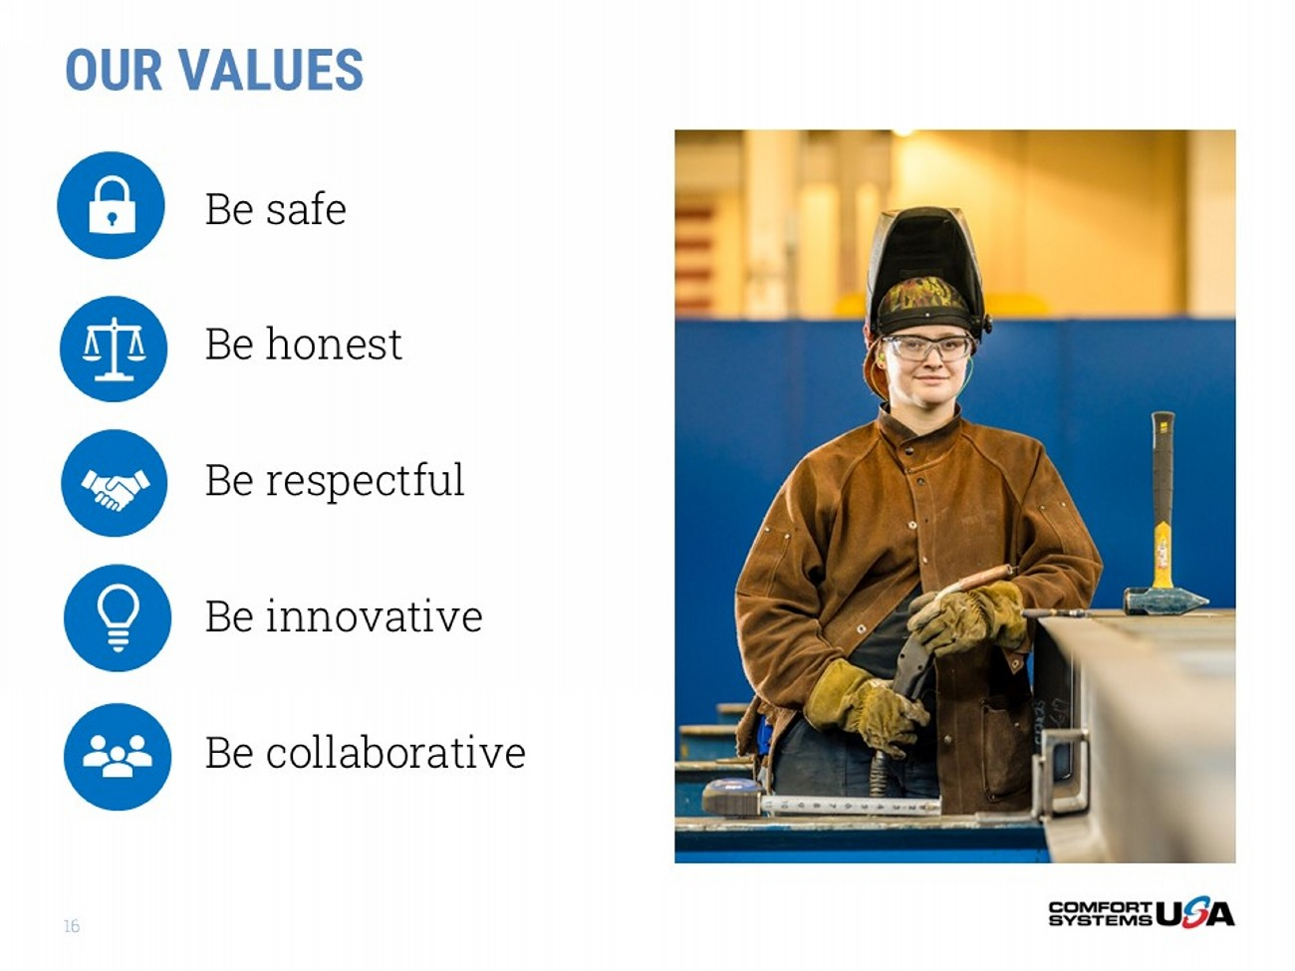
16 Be safe Be honest Be respectful Be innovative Be collaborative OUR VALUES

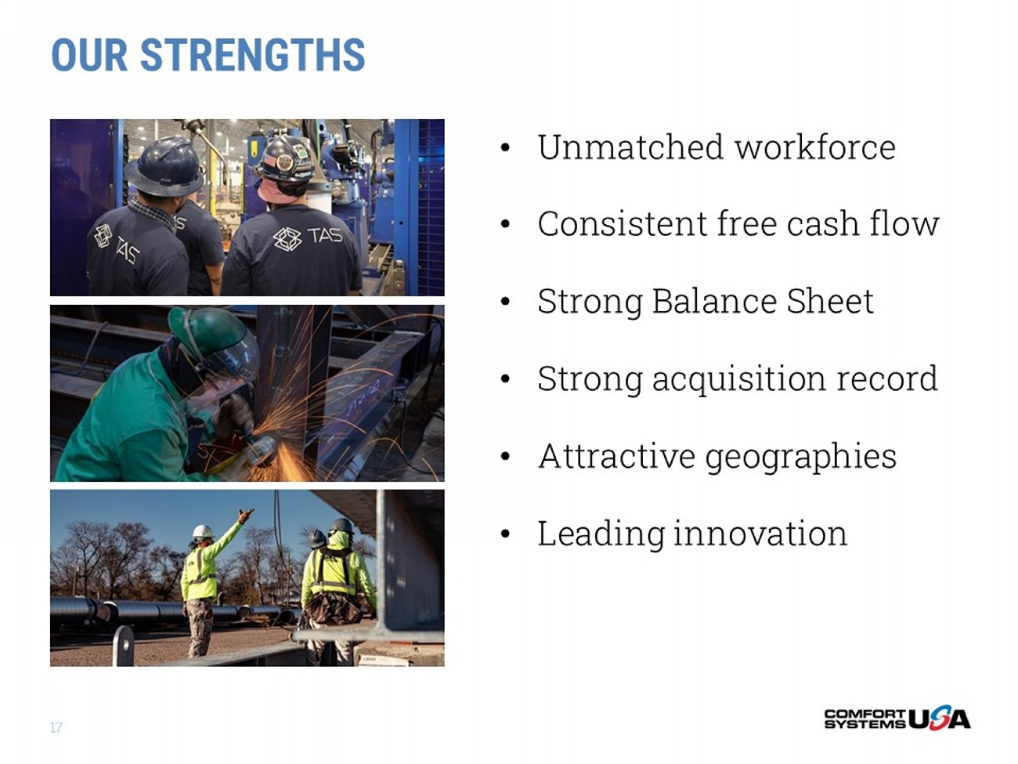
OUR STRENGTHS 17 • Unmatched workforce • Consistent free cash flow • Strong Balance Sheet • Strong acquisition record • Attractive geographies • Leading innovation

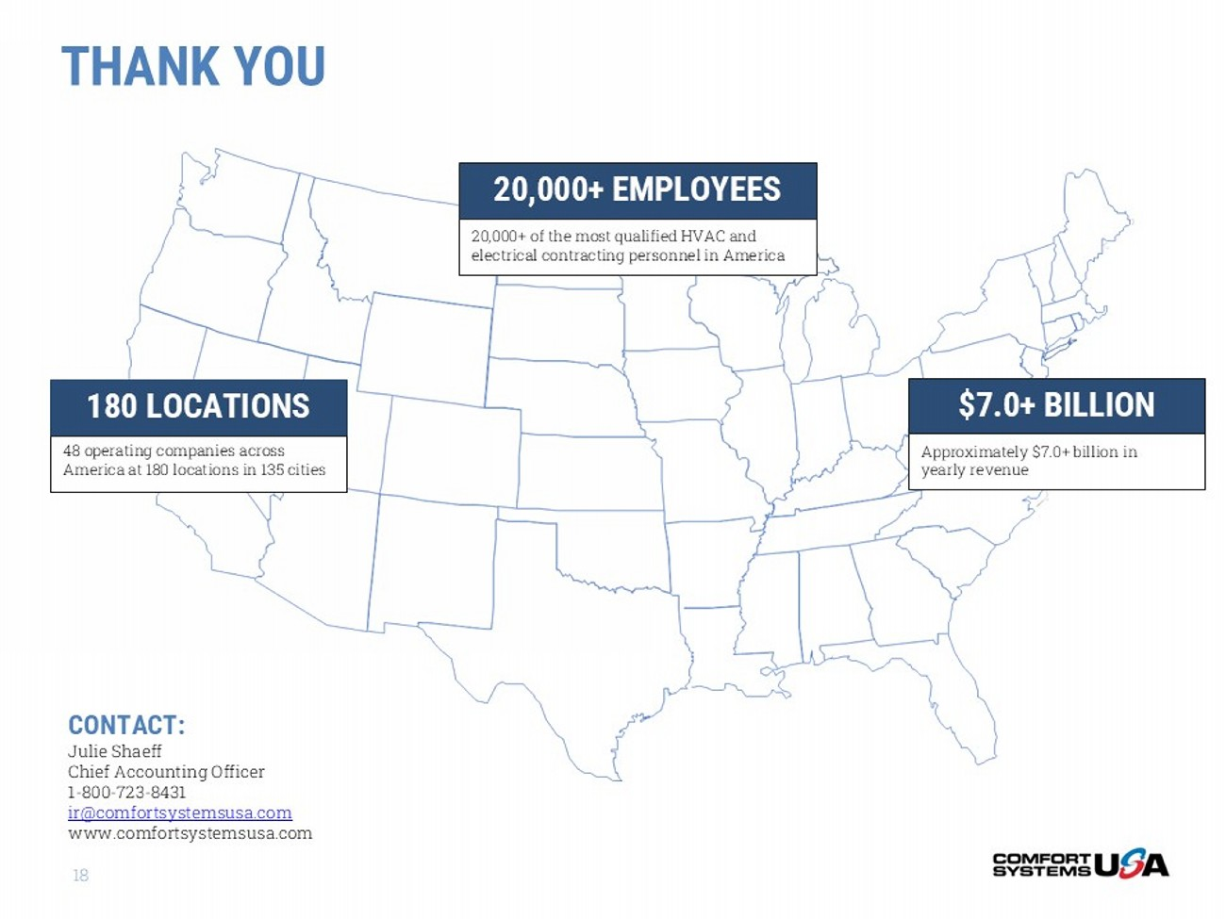
THANK YOU 18 180 LOCATIONS 48 operating companies across America at 180 locations in 135 cities 20,000+ of the most qualified HVAC and electrical contracting personnel in America 20,000+ EMPLOYEES $7.0+ BILLION Approximately $7.0+ billion in yearly revenue CONTACT: Julie Shaeff Chief Accounting Officer 1 - 800 - 723 - 8431 ir@comfortsystemsusa.com www.comfortsystemsusa.com

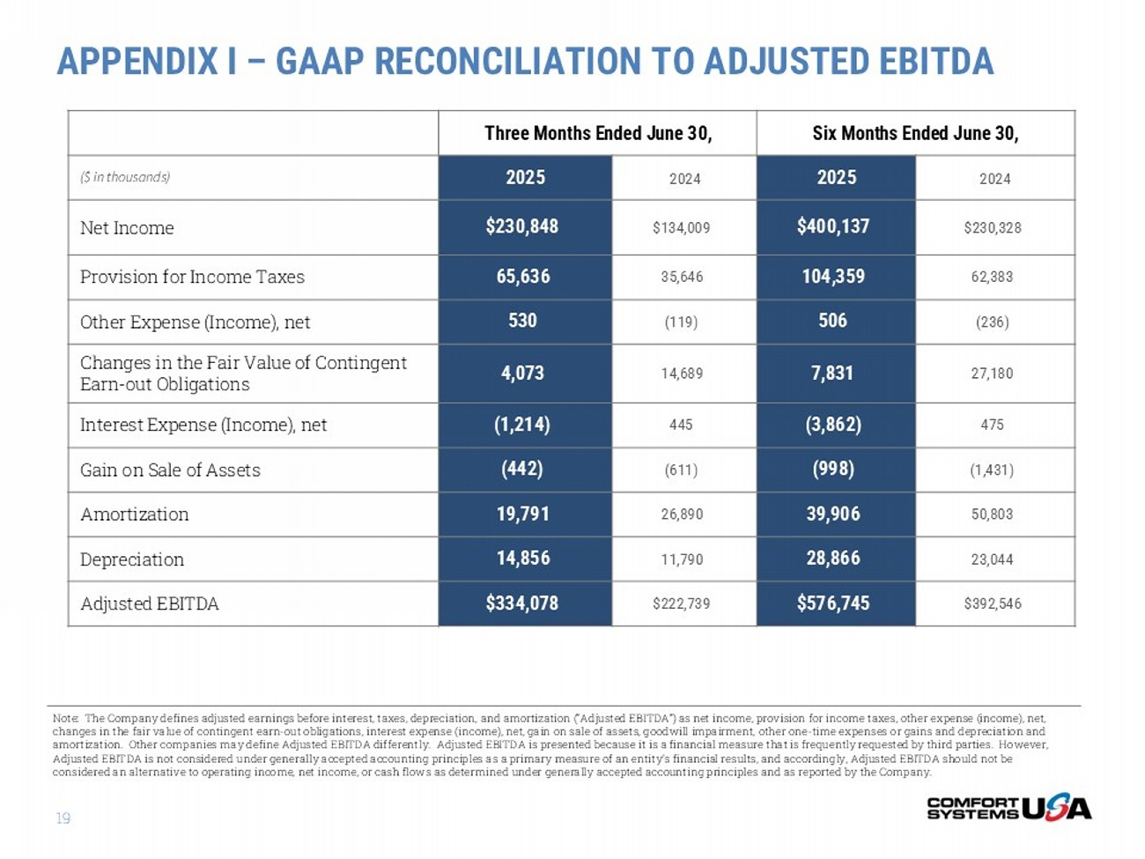
APPENDIX I – GAAP RECONCILIATION TO ADJUSTED EBITDA 19 Six Months Ended June 30, Three Months Ended June 30, 2024 2025 2024 2025 ($ in thousands) $230,328 $400,137 $134,009 $230,848 Net Income 62,383 104,359 35,646 65,636 Provision for Income Taxes (236) 506 (119) 530 Other Expense (Income), net 27,180 7,831 14,689 4,073 Changes in the Fair Value of Contingent Earn - out Obligations 475 (3,862) 445 (1,214) Interest Expense (Income), net (1,431) (998) (611) (442) Gain on Sale of Assets 50,803 39,906 26,890 19,791 Amortization 23,044 28,866 11,790 14,856 Depreciation $392,546 $576,745 $222,739 $334,078 Adjusted EBITDA Note: The Company defines adjusted earnings before interest, taxes, depreciation, and amortization (“Adjusted EBITDA”) as ne t i ncome, provision for income taxes, other expense (income), net, changes in the fair value of contingent earn - out obligations, interest expense (income), net, gain on sale of assets, goodwill i mpairment, other one - time expenses or gains and depreciation and amortization. Other companies may define Adjusted EBITDA differently. Adjusted EBITDA is presented because it is a financia l m easure that is frequently requested by third parties. However, Adjusted EBITDA is not considered under generally accepted accounting principles as a primary measure of an entity’s financia l r esults, and accordingly, Adjusted EBITDA should not be considered an alternative to operating income, net income, or cash flows as determined under generally accepted accounting pr inc iples and as reported by the Company.

